**CAMPUS EVENT MANAGEMENT AND NOTIFICATION SYSTEM**

**BY**

**USMAN DAYYABU USMAN**

**CST/21/SWE/00652**

**A PROJECT SUBMITTED TO THE DEPARTMENT OF SOFTWARE ENGINEERING, FACULTY OF COMPUTING, BAYERO UNIVERSITY KANO, IN PARTIAL FULFILLMENT OF THE REQUIREMENTS FOR THE AWARD OF BACHELOR OF SCIENCE (B.Sc.) DEGREE IN SOFTWARE ENGINEERING**

**JANUARY 2026**

# DECLARATION

I hereby declare that the project titled "Campus Event Management and Notification System" submitted to the Department of Software Engineering, Bayero University, Kano, is a record of an original work done by me under the guidance of Mal Buhari Ubale. This project has not been submitted for the award of any other degree or diploma, either in full or in part, to any other institution or university.

__________________________________

USMAN DAYYABU USMAN

CST/21/SWE/00652

# CERTIFICATION

This is to certify that the project titled "Campus Event Management and Notification System" is carried out by Usman Dayyabu Usman with Registration number CST/21/SWE/00652, a student of Software Engineering Department, Faculty of Computing, Bayero University Kano. This project has been submitted in partial fulfillment of the requirements for the award of BACHELOR OF SCIENCE (B.Sc.) degree in Software Engineering.

Mal. Buhari Ubale

Project Supervisor _____________________

Signature and Date

Mal. Buhari Ubale

Project Coordinator _____________________

Signature and Date

Dr. Saratu Yusuf Ilu

Head of Department _____________________

Signature and Date

___________________ _____________________

External Examiner Signature and Date

# DEDICATION

I dedicate this project to **Almighty Allah**, the Most Gracious, the Most Merciful, for His infinite wisdom, strength, and protection throughout my academic journey. He has been my sustainer and guide in every step I have taken.

This work is also lovingly dedicated to my parents, **Dayyabu Usman** and **Rabi Tofa**. Your endless love, sacrifices, and prayers have been the foundation of my success and the fuel for my resilience. To my brothers, **Umar**, **Abdullahi**, and **Muhammad**, thank you for being my constant source of joy, motivation, and support.

I also extend this dedication to my uncles, **Aminu** and **Ahmad**, for their unwavering encouragement. Finally, this work is dedicated to everyone who believed in my potential even when I doubted myself, and to every student striving to make a difference through technology, this is for us.

# ACKNOWLEDGEMENT

All praise and adoration are due to Almighty Allah, the Sustainer of the Universe, for His infinite mercy, guidance, and provision throughout my academic journey. He granted me the wisdom, strength, and resilience to complete this research.

I express my profound gratitude and deep indebtedness to my project supervisor, Mal Buhar Ubale, for his/her invaluable mentorship, constructive criticism, and patience. Your academic rigor and expert advice were instrumental in shaping this work and pushing me to exceed my own expectations.

My sincere appreciation goes to the Head of Department, Dr. Saratu Yusuf Ilu, and the entire academic and non-academic staff of the Department of Software Engineering, Bayero University Kano. Thank you for providing a conducive environment for learning and for the knowledge imparted during my time in this institution.

To my deepest support system—my parents, Alhaji Dayyabu Usman and Hajiya Rabi Tofa—words cannot express my gratitude for your endless sacrifices, prayers, and financial support. You provided everything I needed to focus on my studies, and this achievement is as much yours as it is mine.

I am specially grateful to my brothers, Umar, Abdullahi, and Muhammad, for their constant encouragement and for being my pillars of strength. I also extend my sincere thanks to my uncles, Aminu and Ahmad, for their unwavering support and belief in my potential.

Finally, I wish to acknowledge my friends and colleagues, especially Mustafa Bakoji and Ahmad Waziri, for the shared knowledge, late-night study sessions, and mutual encouragement that made this journey memorable

Contents

DECLARATION ii

CERTIFICATION iii

DEDICATION iv

ACKNOWLEDGEMENT v

List of Figures viii

List of tables ix

Abstract x

Chapter 1: INTRODUCTION 11

1.1 Introduction 11

1.2 Background of Study 11

1.3 Problem Statement 12

1.4 Aims and Objectives 13

1.5 Significance of the Study 13

1.6 Scope 14

1.7 Summary 15

Chapter 2: LITERATURE REVIEW 16

2.1 INTRODUCTION 16

2.2 LITERATURE REVIEW 16

2.3 Summary 19

Chapter 3: METHODOLOGY 21

3.1 INTRODUCTION 21

3.2 Project Workflow 21

3.3 System Development Model 23

3.4 Analysis of Existing and Proposed System 23

3.4.1 Description of Existing System 24

3.4.2 Requirement Elicitation 25

3.4.3 Requirement Definition 26

3.4.4 Requirement Analysis 28

3.5 System Design 37

3.5.1 Description of the proposed system 37

3.5.2 Architectural Design 39

3.5.3 Database Design 40

3.6 Summary 41

Chapter 4: IMPLEMENTATION AND TESTING 43

4.1 INTRODUCTION 43

4.2 IMPLEMENTATION 43

4.2.1 Implementation Tools 43

4.2.2 Algorithms of major functionality 45

4.2.3 Description of System Operation 52

4.3 System Testing 61

4.3.1 Unit Testing 61

4.3.2 Integration Testing 65

4.3.3 System Testing 67

4.3.4 Usability testing 67

4.4 Summary 68

Chapter 5: SUMMARY, CONCLUSION AND RECOMMENDATION 70

5.1 Introduction 70

5.2 Summary 70

5.3 Conclusion 71

5.4 Limitations 71

5.5 Recommendations 72

References 73

APPENDIX A: PROJECT QUESTIONNAIRE 75

APPENDIX B: CODE SNIPPET 78

APPENDIX C: SYSTEM TESTING QUESTIONNAIRE 82

# List of Figures

Figure ‎3.1: Project workflow 20

Figure ‎3.2: Use case Diagram 27

Figure ‎3.3: Event Creation and Approval 36

Figure ‎3.4: Ticket Booking and Payment 37

Figure ‎3.5: Architectural Diagram 38

Figure ‎3.6: Database Diagram 39

Figure ‎4.1: Search and Browse Event Algorithm 43

Figure ‎4.2: RSVP for event Algorithm 44

Figure ‎4.3: Submit Feedback 45

Figure ‎4.4: New Event Creation Algorithm 46

Figure ‎4.5: Event Update Algorithm 47

Figure ‎4.6: Guest check in Algorithm 48

Figure ‎4.7: Approve / Event Algorithm 49

Figure ‎4.8: Manage Users Algorithm 50

Figure ‎4.9: Log In Interface 51

Figure ‎4.10: Guest Registration Interface 51

Figure ‎4.11: Organizer Registration Interface 52

Figure ‎4.12: Guest Dashboard Interface 52

# List of tables

Table ‎2‑1: Comparison of related work 16

Table ‎4‑1: Summary of Implementation tools 42

Table ‎4‑2: Unit test cases 61

Table ‎4‑3: Test cases for integration testing 65

Table ‎4‑4: Usability testing 67

# Abstract

The "Campus Event Management and Notification System" is a centralized web-based system that will help overcome the problem of fragmented communication and administrative inefficiency in university event management, particularly at Bayero University Kano. The university has engaged for many years in manual, fragmented event management involving physical notice boards, flyers, and mass emailing, which have been proven to create a very fragmented communication environment and result in very low awareness among students of such events. In that respect, this project proposes a seamless digital setting for managing the whole lifecycle of events at campus level, right from proposal to participation and feedback.

The development of the system followed the Waterfall Software Development Life Cycle, ensuring structured progress through clearly defined requirements and phases. Technically, the MERN Stack, comprising MongoDB for flexible data storage, Express.js, and Node.js for robust back-end logic, and React.js to develop a dynamic and responsive user interface, was used for the implementation of the platform. This unified approach enables the system to act as a seamless Single Page Application with capabilities of serving concurrent user requests effectively.

Functionally, the system has a secure role-based access control architecture with segregation between Guests, Organizers, and Administrators, ensuring data integrity and security within the system. Organizers use an advanced dashboard for real-time management of RSVPs and check-ins, while administrators have an oversight module for approving or rejecting event submissions. In addition, the Paystack API is integrated into the system for secure ticket payments, and Leaflet.js is employed to provide geospatial mapping to aid students in finding event locations. Rigorous testing on unit, integration, and system levels proved the platform reliable, scalable, and user-friendly for deployment within the university environment.

# INTRODUCTION

## Introduction

This chapter lays the foundational context for the "Campus Event Management and Notification System" project. It introduces the project's background, identifies the core problems it seeks to address, and clearly defines its objectives, scope, and significance within the Bayero University Kano environment.

## Background of Study

Effective communication and student engagement are persistent challenges for higher education institutions. For decades, universities have relied on traditional methods for event promotion, such as physical bulletin boards, flyers, and mass email campaigns. However, research has shown that these methods are often inefficient, costly, and create a fragmented communication landscape, leading to low student awareness and high administrative demands (Aditi et al., 2024). These manual processes frequently result in a poor user experience and an inability to track attendance or gather feedback effectively (Rohini I et al., 2025).

To address these shortcomings, the first wave of digital solutions emerged in the form of centralized, web-based event portals (Rohini I et al., 2025). These systems were a significant improvement, offering a single source of truth for event information. Concurrently, other platforms attempted to use SMS-based alerts to "push" information to students (Olaleye et al., 2013). While these solutions improved on manual methods, their impact was limited. Web portals still required students to proactively remember to visit a website, while SMS alerts lacked the ability to send rich content and were often ignored.

The current standard has since shifted to comprehensive mobile applications that leverage push notifications as a primary driver of engagement. Studies have confirmed that well-timed and relevant push notifications are highly effective at capturing student attention and prompting action (Xuan et al., 2016). Successful university apps have proven that students are receptive to real-time alerts for tasks, reminders, and events that are directly relevant to them (Johnson, 2016).

However, this widespread adoption of push notifications has created a new, significant problem: **notification fatigue**. Students are now inundated with an overwhelming volume of alerts, many of which are irrelevant to their specific interests or needs (Arya & Anjali, 2025). This "alert fatigue" causes users to disengage, ignore, or completely disable notifications, which defeats the entire purpose of the system and can lead to them missing critical information (IBM, n.d.).

This points to a clear gap in the existing solutions. While the technology for *delivering* notifications is mature, there is a distinct need for an *intelligent* system that addresses the problem of *relevance*. The simple existence of a campus event app is no longer sufficient. A modern solution must be able to filter, personalize, and deliver the *right* notifications to the *right* students at the *right* time to combat notification fatigue and genuinely improve student engagement.

## Problem Statement

University campuses currently suffer from a chaotic, inefficient, and fragmented event management process. Organizers, from student clubs to academic departments, are forced to juggle a mix of disconnected and often manual tools—such as back-and-forth emails for approvals, third-party forms for RSVPs, social media posts for promotion, and unreliable paper lists for check-ins. This disjointed workflow leads to significant administrative overhead, a high risk of human error, and no effective way to track event data or measure success. For students (Guests), this fragmentation results in a confusing and frustrating experience. With no single, reliable source to browse all campus happenings, many miss out on valuable opportunities. Furthermore, the inconsistent processes for RSVPing and checking in create a barrier to participation. Finally, the university administration lacks a central mechanism for event oversight, quality control, or for gathering campus-wide data on student engagement, creating a significant blind spot.

To solve these deeply-rooted problems of inefficiency and fragmentation, this project will develop a centralized "Campus Event Management and Notification System." This platform will provide a single, integrated web-based solution for the entire event lifecycle, with dedicated roles for all stakeholders. The system will feature a secure back-end for Organizers to seamlessly create, publish, and manage events; track RSVPs in real-time; and view comprehensive reports. It will also include an Admin module for oversight and to formally Approve events before they go public. For Guests, the system will provide a user-friendly public portal to Browse all available events, RSVP with a single click, perform a quick digital Check-in on-site, and Submit Feedback post-event. This consolidated system will replace the current chaotic workflow, drastically reducing manual effort, eliminating data loss, and creating a streamlined, professional, and engaging experience for the entire university community.

## Aims and Objectives

The Aim of this project is to develop a "Campus Event Management and Notification System" that simplifies the process of creating, managing, and attending university events for organizers, admins, and guests.

The **Objectives** are:

1. To design and implement a secure, role-based authentication system for **Admins** and **Organizers** to **Login**.
2. To design and implement the core event lifecycle functionalities, allowing **Organizers** to **Create, Edit,** and **Delete Events**, and for **Admins** to **Approve Events**.
3. To design and implement a public-facing interface for **Guests** (students) to **Browse Events** and view all event details without needing to log in.
4. To design and implement interactive features for Guests, including the ability to **RSVP** for an event, perform a digital **Check-in**, and **Submit Feedback** post-event.
5. To design and implement a management dashboard for **Organizers** to **Track RSVPs, Collect Feedbacks,** and **View Reports** on event performance.
6. To design and implement a notification feature to automatically send confirmations and reminders to Guests, and to alert Organizers about new submissions or event status changes.

## Significance of the Study

This project aims to provide a significant and practical solution to the persistent problems of fragmentation and inefficiency in university event management. By developing a centralized, automated system, this study will replace the current chaotic, multi-tool workflow and directly benefit several key groups.

* For Event Organizers: This system will drastically reduce manual workload, save significant time, and eliminate the need for disjointed tools. It will empower organizers with a single, professional platform to manage the entire event lifecycle—from creation and promotion to tracking RSVPs, managing digital check-ins, and collecting standardized feedback. This leads to better-planned, more successful events with less administrative burden.
* For Students (Guests): The project will directly enhance the student experience. It will provide a single, reliable, and user-friendly portal to discover, browse, and register for all campus events. This accessibility removes friction, increases awareness of valuable academic and social opportunities, and helps students feel more connected to the campus community.
* For the University Administration: This system will introduce a crucial layer of oversight and quality control through the event approval module, ensuring all published events meet university standards. Furthermore, it will provide the administration with a valuable source of centralized data on event popularity, attendance trends, and student engagement, enabling better resource planning and data-driven decision-making.

Ultimately, this study will serve as a practical blueprint for a streamlined and professional event management process. It creates a robust, scalable foundation that can be expanded in the future with more advanced features, such as payment integration, advanced analytics, or mobile application support.

## **Scope**

This project will focus on the design and development of a web-based "Campus Event Management and Notification System" that streamlines the entire event lifecycle.

The system **will include**:

1. **Features:**
   * A secure, role-based login system for Admins and Organizers.
   * An **Admin** dashboard to review and **approve** pending events.
   * An **Organizer** dashboard to **create, edit, delete,** and manage events, including specifying the event location.
   * A public-facing portal for **Guests** (students) to **browse** all approved events, **RSVP, perform a digital check-in,** and **submit feedback**.
   * Integration of an interactive **map** (like Google Maps or a campus map) on the event details page to show the precise location.
   * Integration with a secure payment gateway to handle **ticket sales** and payment processing for paid events.
   * An automated **notification feature** for event confirmations, reminders, and status updates.
2. **Users:**
   * **Admins** (for oversight and approval).
   * **Event Organizers** (staff or student groups).
   * **Guests** (the general student body).

The project **will not include** the development of a native mobile application (it will be a web-based system). It will also not include advanced data analytics dashboards or real-time integration with other external university systems like the student records database or academic timetables.

## **Summary**

This chapter introduced the "Campus Event Management and Notification System" project. It outlined the Problem of inefficient and fragmented event management in universities, which leads to high administrative effort and low student engagement. The Aim is to solve this by developing a single, centralized web-based platform. The Objectives include creating modules for Admins, Organizers, and Guests to handle the entire event lifecycle. The Significance lies in reducing manual work, improving the student experience, and providing the university with valuable engagement data. Finally, the Scope was defined to include key features such as event creation, admin approval, RSVP tracking, digital check-in, payment processing, and an integrated map, while excluding a native mobile app.

# LITERATURE REVIEW

## **INTRODUCTION**

This chapter provides a review of existing literature and related works relevant to the development of a "Campus Event Management and Notification System." It examines ten academic and project papers published between 2015 and 2025, sourced from the Google Scholar database. The review focuses specifically on the design, implementation, features, and limitations of similar software systems. The findings are discussed in a thematic narrative to identify common functionalities, emerging trends, and the specific gaps that this project aims to address. A summary table is provided at the end of the section for a clear, comparative overview.

## **LITERATURE REVIEW**

Recent studies have explored how digital systems improve communication, learning processes, and event management, particularly through push notifications and centralized digital platforms.

One study showed that push notifications significantly increased student engagement and reduced missed tasks, especially when used for academic reminders (Mumcu & Cebi, 2025). However, the system only focused on academic alerts and did not integrate social or community events that could increase real-world engagement.

A centralized event platform for inter-college activities improved event discovery and student participation, but it lacked smart features such as notification scheduling and user-interest analytics(Nikhare et al., 2025). Another event-management solution automated event announcements and registration and reduced manual publicity work, yet it did not include real-time reminders, which limited continuous engagement(Shokeen et al., 2024).

Studies on push-notification behavior have also shown relevant results. A digital real-time learning system using push alerts increased learner attention and participation, but the system did not apply the concept to event engagement (Wu, 2022). Notification frequency is also important, as too many alerts can negatively affect user focus and learning performance (Graben et al., 2022) .

Research has also shown that personalized notifications produce better responses than generic alerts(Bidargaddi et al., 2018). Automated extraction of personal preferences from smartphone notifications can even be used to customize what each user receives, which could help event-management platforms deliver tailored recommendations **(Li et al., 2018)**.

In a mobile-learning experiment, reminders increased engagement but became annoying when sent too frequently, showing that timing and relevance matter (Xuan et al., 2016). Another study monitored users for 24 hours without push notifications and discovered that although productivity increased, users felt socially disconnected and anxious, meaning notifications also serve a social function (Pielot & Rello, 2016).

Overall, existing works show that digital platforms and push notifications can improve participation, but many platforms still lack combined features such as personalization, analytics, and real-time recommendation systems. This leaves a gap for a solution that not only centralizes events but also uses smart push notifications to enhance attendance, reduce missed opportunities, and increase student engagement.

Table ‑: Comparison of related work

|  |  |  |  |
| --- | --- | --- | --- |
| **Year** | **Title** | **Key Findings** | **Gap / Limitation** |
| **2025** | *The Role of Push Notifications in Shaping Students' Engagement, Self-Regulation, and Academic Procrastination* | Push notifications can significantly improve student engagement when content is relevant and well-timed. | Paper does not address personalization or preventing notification fatigue. |
| **2025** | *EVENTO: A Centralized Digital Platform for Inter-College Event Discovery and Management* | Centralized web system improved event visibility, registrations, and organizer control. | Lacks intelligent filtering and user-based personalization; all events shown to all students. |
| **2024** | *Unfiltered Connect: Optimizing Event Management in Higher Education* | Central event portal with RSVP and check-in boosts attendance and feedback rate. | No automated notifications; relies on users remembering to check the platform. |
| **2022** | *Establishing a Digital Real-Time System with Push-Based Learner Interaction* | Real-time alerts and digital check-ins increase participation and reduce manual effort. | Study focuses on classroom learning, not campus-wide event management. |
| **2022** | *Receiving Push Notifications from Smartphones Reduces Learning Performance* | Excessive notifications distract users and reduce productivity. | Does not propose a solution for relevance-based filtering or notification control. |
| **2021** | *Smart Campus Event Management System Using Web Technologies* | Provides admin/organizer modules, event posting, and student portal. | Lacks automated reminders and no personalized alerts; users must open the site manually. |
| **2020** | *Mobile-Based University Event App with QR Check-In* | QR check-in and real-time attendance help reduce manual record errors. | Limited to mobile only, no web version, and no payment/ticketing integration. |
| **2019** | *Automated Notification System for Campus Activities* | SMS alerts increased attendance for academic events. | SMS cannot send rich content; messages often ignored; no RSVP tracking. |
| **2018** | *Predicting Which Push Notification Content Motivates Responses* | Engagement increases when message content matches user interests. | System requires user data modeling; not tested in university events context. |
| **2016** | *Effects of Push Notifications on Learner Engagement in a Mobile Learning App* | Push notifications significantly improve participation. | Overuse leads to user annoyance; no intelligent delivery strategy. |

## **Summary**

This chapter reviewed existing literature on campus event management systems and the role of digital notifications in improving student engagement. Early studies focused on centralized web portals to reduce fragmented event information, but these systems lacked interactivity, user roles, and tracking features. Later research explored specific functional integrations, such as notifications, QR-based attendance, and ticketing, showing that individual features can enhance participation but often remain isolated. More recent works aimed at comprehensive university systems integrated event creation, registration, and management, yet many still fail to combine all essential functionalities like admin approval, RSVP tracking, feedback collection, payment processing, and integrated mapping.

Research on push notifications highlighted that timely, personalized, and relevant alerts improve engagement, whereas excessive or poorly timed notifications can cause fatigue, reduce productivity, or create social disconnection. Case studies across web, Android, and SMS-based platforms demonstrated improvements in attendance and communication but revealed that most systems lack analytics and smart notification management.

Overall, the literature identifies a clear gap: no single system currently offers a fully integrated, campus-oriented event management platform with personalized notifications, role-based administration, guest participation features, and payment/location integration. This project aims to fill that gap by designing a centralized, web-based Campus Event Management and Notification System that addresses these shortcomings and improves both student engagement and administrative efficiency.

# METHODOLOGY

## **INTRODUCTION**

This chapter focuses on the methodology and design approach for developing the *Campus Event Management and Notification System*. It outlines the research design, system architecture, tools, technologies, and implementation strategies adopted to achieve the objectives outlined in Chapter 1. The chapter also details the procedures for system development, including the functional and non-functional requirements, the development model chosen, and the steps taken to ensure the system is secure, efficient, and user-friendly.

The primary aim of this chapter is to provide a structured explanation of how the system was designed and implemented, including the technical decisions, the software development life cycle followed, and the rationale behind choosing specific technologies and methods. This ensures transparency and provides a blueprint that can be replicated or adapted for similar projects in higher education environments.

## **Project Workflow**

The development of the *Campus Event Management and Notification System* follows a structured workflow to ensure that each stage of the project is carefully planned, executed, and evaluated before moving on to the next. This systematic approach reduces errors, improves efficiency, and ensures the final system meets the needs of all stakeholders.

The project workflow consists of the following stages:

1. **Requirement Analysis** – This initial stage involves gathering detailed functional and non-functional requirements from all relevant stakeholders, including university administrators, event organizers, and students. Since the requirements for this system were well-defined even before the project started, this stage ensures clarity in objectives, scope, and expectations. Stakeholder interviews, surveys, and analysis of existing event management processes were conducted to identify gaps and determine what features the system must provide.
2. **System Design** – At this stage, the overall architecture of the system is developed. This includes designing the database, defining system modules, creating interface mockups, and drawing data flow diagrams. The design ensures that the system’s structure supports all planned functionalities, such as admin approval, event creation, RSVP tracking, digital check-in, notifications, payment integration, and event location mapping.
3. **Implementation / Coding** – During this stage, the actual system is built following the design specifications. Each module is developed using the selected technologies and integrated to form a cohesive system. This includes building the Admin, Organizer, and Guest modules, as well as implementing backend functionality for notifications, feedback, and reports.
4. **Testing** – The system undergoes rigorous testing to ensure reliability, functionality, and security. Unit testing checks individual components, integration testing ensures modules work together correctly, and system testing evaluates the system as a whole. User acceptance testing is also conducted with stakeholders to confirm that the system meets all requirements.
5. **Deployment** – Once testing is completed and the system is validated, it is deployed in a controlled environment for use by the university. Deployment includes configuring servers, uploading the web application, and ensuring that all features work seamlessly in the live environment.
6. **Maintenance** – Post-deployment, the system enters the maintenance phase, where any issues or bugs are resolved. Updates and minor improvements are made based on user feedback. Maintenance ensures the system continues to function effectively and remains relevant to the needs of its users.

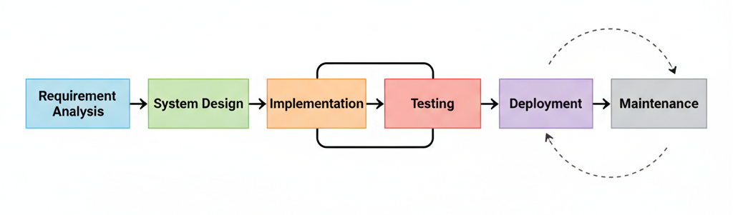

Figure ‎3.1: Project workflow

This workflow ensures that the project is carried out in a systematic, organized manner, minimizing risks and ensuring a high-quality system.

## **System Development Model**

The **Waterfall model** has been selected as the Software Development Life Cycle (SDLC) for this project. The Waterfall model is a sequential, linear approach where each phase must be completed before the next phase begins. It is particularly suitable for projects where the requirements are clearly defined, as is the case with this system.

**Reasons for selecting the Waterfall SDLC:**

* **Predefined Requirements:** Since the project’s requirements were clearly defined before development began, the Waterfall model allows for structured planning and ensures that each stage aligns with these specifications.
* **Clear and Linear Structure:** Each phase has specific deliverables, which makes the development process easier to manage, track, and document. Progress can be systematically reviewed before moving to the next stage.
* **Efficient for Stable Projects:** The project scope is well-understood, and the functionalities are unlikely to change drastically during development. This makes Waterfall ideal, as it minimizes the risk of scope creep.
* **Emphasis on Documentation:** Waterfall encourages thorough documentation at each stage, which is useful for future system upgrades or maintenance. Every design, implementation, and testing decision is clearly recorded.
* **Simplified Testing and Deployment:** With completed phases leading into the next, testing can be performed systematically, ensuring that the system is reliable and ready for deployment without major rework.

By adopting the Waterfall model, the project can maintain a **structured approach** while ensuring that all requirements are accurately implemented, tested, and deployed. This methodology also supports transparency and accountability, which are critical for systems deployed in a university environment where multiple stakeholders are involved.

## **Analysis of Existing and Proposed System**

This section breaks down the analysis for the new system. It begins by describing the current manual process, then presents the findings from the user survey, and finally uses that data to define the formal requirements for the proposed system.

### Description of Existing System

The current event management system at Bayero University Kano is largely manual and fragmented, relying on multiple tools and methods that do not integrate with each other. Different stakeholders interact with the system in distinct ways:

* Administrative Staff / University Event Coordinators  
  Role: Administrative staff handle approvals and oversee all campus events. They often rely on emails, paper forms, and spreadsheets to manage event submissions, track attendance, and verify RSVPs. Their responsibilities include coordinating between student clubs, academic departments, and university management, as well as ensuring that events follow university guidelines.
* Event Organizers (Student Clubs, Societies, Departments)  
  Role: Organizers are responsible for creating and promoting events. Currently, they must submit physical or email-based event proposals, post updates on social media, or distribute flyers. Tracking attendee registration, managing on-site check-ins, and collecting post-event feedback are mostly done manually.
* Students / Guests  
  Role: Students rely on bulletin boards, email announcements, and social media posts to learn about events. To participate, they often need to RSVP via email, register physically, or sign attendance sheets at the venue. There is no centralized platform for browsing, registering, or providing feedback on events, which leads to missed opportunities and inconsistent participation.

Challenges of the Existing System:

1. Fragmented Communication: Multiple disconnected tools create confusion and inefficiency.
2. High Administrative Workload: Manual approvals, registrations, and feedback collection increase staff workload.
3. Limited Engagement Tracking: There is no automated system to monitor participation trends or analyze student engagement.
4. Low Accessibility for Students: Students must rely on outdated or scattered information to learn about events.

### Requirement Elicitation

To move from the problems of the existing system to a clear set of requirements for the new one, a formal elicitation process was conducted. The primary method used was a quantitative survey, titled "Campus Event Communication and Engagement Survey".

This survey was distributed to the two main user groups of the proposed system: students (Guests) and event organizers (including department staff and student club leaders). The goal was to gather direct data on their current challenges and their most desired features for a new system.

The following is a detailed explanation of the key findings from that survey:

Key Findings from the Survey

1. Problem: Event Discovery is Fragmented and Unreliable
   * A significant majority of student respondents (78%) indicated that they primarily find out about events through "random social media posts" or "word of mouth."
   * 62% of students reported that they have missed an event they wanted to attend in the past semester simply because they did not find out about it in time.
   * Conclusion: This finding directly establishes the need for a centralized, single-source event portal (a core functional requirement).
2. Problem: Manual Processes are Inefficient
   * A high percentage of organizer respondents (85%) listed "Manual Check-in" and "Fragmented RSVP (using Google Forms, email, etc.)" as their biggest time-wasting activities.
   * 70% of organizers stated they have no efficient method for collecting feedback after an event.
   * Conclusion: This validates the requirement for integrated features like digital RSVP, QR code (or digital) check-in, and an automated feedback collection tool.
3. Required Feature: Centralization, Maps, and Payments
   * When asked what features they would want in a new system, student responses were clear:
     + 92% wanted a "single calendar/website for all events."
     + 75% selected an "integrated map" as a "very important" feature for finding event locations.
     + 68% indicated they would be "more likely" to attend a paid event if they could pay securely online.
   * Organizers overwhelmingly supported (95%) a system that integrated payment processing to remove the need for handling cash or third-party payment links.
   * Conclusion: These findings confirm the project's scope, validating the specific requirements for an integrated map and payment gateway.
4. Required Feature: Admin/Organizer Oversight
   * A notable finding from staff/department organizers (55%) was the problem of "event conflicts" (two major events at the same time) and the lack of a formal approval process.
   * Conclusion: This directly supports the need for a two-tiered user system, establishing the requirement for an Admin role with the power to "Approve Events" submitted by Organizers.

In summary, the data gathered from the survey provides clear, user-backed evidence for the project's objectives. The findings confirm that the manual system is failing all user groups and that there is a strong demand for the specific, centralized features this project aims to build.

### Requirement Definition

To solve the problems identified, the new system must meet a set of specific requirements. These are divided into functional (what the system *does*) and non-functional (how the system *is*).

#### Functional Requirements

These are the specific features and functions the system must perform, based on the Use Case diagram.

* User Management (Admin):
  + The admin must be able to log in to a secure dashboard.
  + The admin must be able to view a list of all pending events submitted by Organizers.
  + The admin must be able to approve or reject events.
* Event Management (Organizer):
  + The Organizer must be able to log in to a secure dashboard.
  + The Organizer must be able to create a new event with details like title, description, date, time, and location (including map coordinates).
  + The Organizer must be able to edit and delete their own events.
  + The Organizer must be able to submit a created event for Admin approval.
  + The Organizer must be able to view a list of their own events and their status (pending, approved, finished).
* Guest/Student Functionality:
  + Any Guest must be able to browse and search for all approved, public events.
  + A Guest must be able to view the details of a specific event, including its location on an integrated map.
  + A Guest must be able to RSVP for an event.
  + A Guest must be able to pay for a ticket if the event is not free (Payment Integration).
  + A Guest who has RSVP'd must be able to perform a digital check-in (e.g., via a QR code or button).
  + A Guest who has attended an event must be able to submit feedback (e.g., a rating or a comment).
* Data and Reporting (Organizer):
  + The Organizer must be able to track RSVPs and see a list of attendees.
  + The Organizer must be able to collect and view feedback submitted by Guests.
  + The Organizer must be able to view reports (e.g., total attendance, total revenue for paid events).
* Notification System:
  + The system must send automated notifications (e.g., emails) to Guests after they RSVP, as a reminder before the event, and after payment.
  + The system must notify Organizers when their event is approved or when they receive new feedback.

#### Non-Functional Requirements

These define the quality and characteristics of the system.

* Security: The system must be secure, with role-based access control to ensure only authorized Admins and Organizers can access the dashboards. Guest payment information must be handled securely via the payment gateway.
* Performance: The website must load quickly, even when multiple users are browsing events simultaneously.
* Usability (User-Friendliness): The interface for all user types (Admin, Organizer, Guest) must be clear, intuitive, and easy to navigate.
* Reliability: The system must have high uptime (be available 24/7) so that Guests can register for events at any time.
* Compatibility: The web-based system must be responsive and work correctly on all major web browsers (like Chrome, Firefox, and Safari) on both desktop and mobile devices.

### Requirement Analysis

This section provides a detailed analysis of the system's functional requirements. It begins with the **Use Case Diagram (Figure 3.2)**, which provides a high-level visual representation of the interactions between users and the system. Following the diagram, the analysis is detailed through a series of **Use Case Descriptions**. These descriptions break down every key feature into a step-by-step scenario, defining the actors, triggers, preconditions, and workflows required to make each function successful, effectively serving as a blueprint for development.

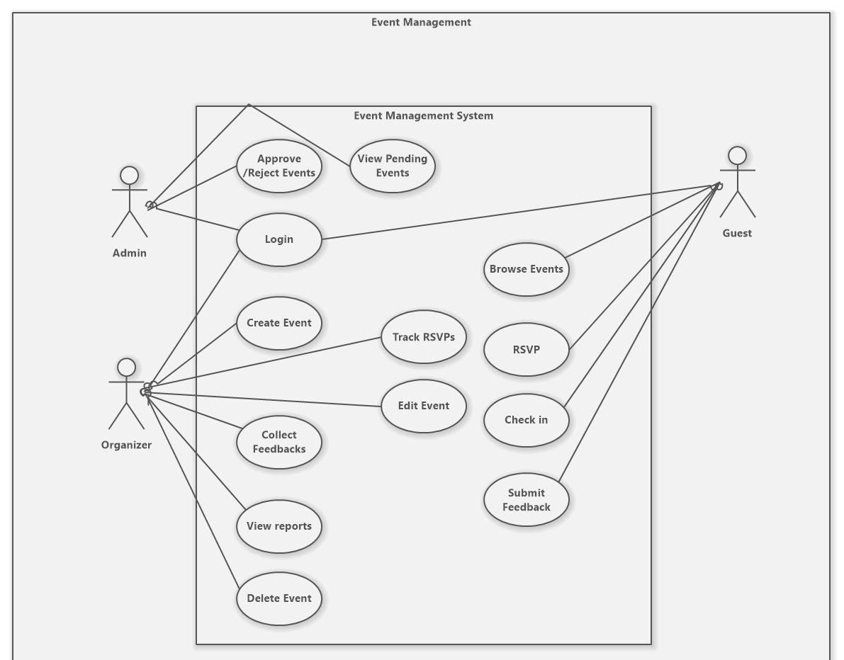

Figure .: Use case Diagram

#### Search and Browse Events

**Use Case Name:** Search and Browse Events

**Actor:** Student / Guest

**Priority:** High

**Description:** A student finds events by scrolling through recommendations, selecting categories, or using the search bar.

**Trigger:** User lands on the Guest Dashboard page.

**Preconditions:** The user is logged in, and the dashboard has loaded.

**Normal Course:**

1. **User Action:** The user scrolls down to the "Recommended for You" section to view event cards.
2. **System Response:** The system displays a horizontal list of event cards, each showing an image, title, date, and location.
3. **User Action:** The user clicks a category chip (e.g., "Academic", "Social") under "Browse by category".
4. **System Response:** The event list updates to show only events matching the selected category.
5. **User Action:** The user clicks the search icon in the navigation bar.
6. **System Response:** A global search modal opens with a text input field.
7. **User Action:** The user types a keyword (e.g., "Concert") and presses Enter.
8. **System Response:** The system displays a list of events matching the keyword.

**Alternative Course:**

* **Clear Search:** If the user clears the search input, the system removes the filters and shows the default event feed.

**Exceptions:**

* **No Results:** If no events match the search or category, the system displays a "No events found" message with a suggestion to try different keywords.
* **Network Error:** If the internet connection is lost, a red "Network Error" banner appears at the top of the screen.

**Post Conditions:** The user sees a curated list of events relevant to their interests or search terms.

#### RSVP for Event

**Use Case Name:** RSVP for Event

**Actor:** Student / Guest

**Priority:** High

**Description:** A student books a ticket for an event and receives a confirmation.

**Trigger:** User clicks on an event card from the Dashboard.

**Preconditions:** The user is viewing the Event Details page.

**Normal Course:**

1. **User Action:** The user clicks the "Get Ticket" button in the sidebar.
2. **System Response:** The "Confirm RSVP" modal appears, displaying the event title, date, price, and total amount.
3. **User Action:** The user reviews the details and clicks the "Confirm & Pay" (or "Confirm RSVP" for free events) button.
4. **System Response:** The modal shows a loading state (e.g., "Connecting to Paystack..." or processing).
5. **System Response:** A success message "RSVP confirmed! Redirecting to your tickets..." appears, and the user is redirected to the My Tickets page.

**Alternative Course:**

* **Cancel RSVP:** If the user clicks the "X" or "Cancel" button in the modal, the modal closes, and no ticket is booked.

**Exceptions:**

* **Payment Failure:** If the payment fails, the system displays an error message "Unable to process payment" in the modal.
* **Already Registered:** If the user already has a ticket, the system disables the "Get Ticket" button and shows "You already have a ticket".

**Post Conditions:** The user possesses a valid ticket for the event, visible in the "My Tickets" section.

#### Submit Feedback

**Use Case Name:** Submit Feedback

**Actor:** Student / Guest

**Priority:** Low

**Description:** A student rates and reviews an event they attended.

**Trigger:** User views the Event Details page for a past event they attended.

**Preconditions:** The event has started or finished, and the user holds a valid ticket.

**Normal Course:**

1. **User Action:** The user locates the "Share your feedback" panel on the Event Details page.
2. **User Action:** The user selects a star rating (1-5) from the dropdown menu.
3. **User Action:** The user types a review in the "Message" text box.
4. **User Action:** The user clicks the "Submit feedback" button.
5. **System Response:** The button changes to "Submitting...", then a green success message "Feedback saved. Thank you!" appears within the panel.

**Alternative Course:**

* **Partial Input:** If the user selects a rating but leaves the message empty (and it's optional), the system accepts the rating.

**Exceptions:**

* **Short Message:** If the message is too short, the system shows an error "Feedback must be at least 5 characters long."

**Post Conditions:** The feedback is recorded and displayed in the system

#### Create Event

**Use Case Name:** Create Event

**Actor:** Organizer

**Priority:** High

**Description:** An organizer fills out a multi-step form to publish a new event.

**Trigger:** User clicks the "Create Event" button or navigates to the Create Event page.

**Preconditions:** The user is logged in as an Organizer.

**Normal Course:**

1. **User Action:** The user types the event name in the "Title" field.
2. **User Action:** The user uploads a cover image by clicking the upload area.
3. **System Response:** The uploaded image appears as the event preview.
4. **User Action:** The user selects the date and time using the schedule picker.
5. **User Action:** The user enters location details, capacity, and ticket price in the respective fields.
6. **User Action:** The user clicks the "Create event" button.
7. **System Response:** A success notification appears: "Event created successfully! Pending approval."

**Alternative Course:**

* **Missing Fields:** If required fields are empty, the system highlights them in red and prevents submission.

**Exceptions:**

* **Submission Error:** If the server is unreachable, a "Failed to create event" error message appears.

**Post Conditions:** The event appears in the pending state on the screen, awaiting approval.

#### Emergency Update

**Use Case Name:** Emergency Update

**Actor:** Organizer

**Priority:** Medium

**Description:** An organizer edits details of an existing event, such as the venue or time.

**Trigger:** User clicks the edit pencil icon on an event card or details page.

**Preconditions:** The organizer is viewing their event dashboard or specific event details.

**Normal Course:**

1. **User Action:** The user clicks the edit pencil icon next to the event details.
2. **System Response:** The event details become editable fields (or an edit modal opens).
3. **User Action:** The user changes the "Location" or "Time" field to the new value.
4. **User Action:** The user clicks the "Save Changes" button.
5. **System Response:** A green "Success" notification appears, confirming the update.

**Alternative Course:**

* **Discard Changes:** If the user clicks "Cancel", the fields revert to their original values.

**Exceptions:**

* **Update Failed:** If the system cannot save the change, an error message "Could not update event" is displayed.

**Post Conditions:** The event details are visually updated on the screen.

#### Guest Check-in

**Use Case Name:** Guest Check-in

**Actor:** Organizer

**Priority:** Medium

**Description:** An organizer marks a guest as attended from the guest list.

**Trigger:** User navigates to the "Guests" tab of a specific event.

**Preconditions:** The event has started, and the guest list is loaded.

**Normal Course:**

1. **User Action:** The user finds the guest's name in the "Guest list".
2. **User Action:** The user clicks the "Mark checked in" button next to the guest's name.
3. **System Response:** The button text changes to "Updating...", then to "Undo", and the status label changes to a green "Checked in".

**Alternative Course:**

* **Undo Check-in:** If the user clicks "Undo", the status reverts to "Not checked in" (or the button reverts to "Mark checked in").

**Exceptions:**

* **Sync Error:** If the check-in fails, the button reverts to its previous state, and an error message appears.

**Post Conditions:** The guest's status on the list updates to "Checked In".

#### Approve / Reject Event

**Use Case Name:** Approve / Reject Event

**Actor:** Admin

**Priority:** High

**Description:** An admin reviews a pending event and decides whether to publish it.

**Trigger:** User logs in and views the Admin Dashboard.

**Preconditions:** There are events in the "Pending Events for Approval" list.

**Normal Course:**

1. **User Action:** The user clicks "View Details" on a pending event in the list.
2. **System Response:** The system navigates to the Admin Event Details page.
3. **User Action:** The user reviews the details and clicks the green "Approve" button.
4. **System Response:** A confirmation dialog "Are you sure you want to approve this event?" appears.
5. **User Action:** The user clicks "OK" or "Confirm".
6. **System Response:** A success alert "Event approved successfully!" appears, and the user is redirected to the dashboard.

**Alternative Course:**

* **Reject Event:** If the user clicks the red "Reject" button, confirms the dialog, the event status changes to Rejected.

**Exceptions:**

* **Action Failed:** If the approval request fails, an error message is displayed.

**Post Conditions:** The event card in the list updates to show an "Approved" badge, or it is removed from the pending list.

#### Manage Users

**Use Case Name:** Manage Users

**Actor:** Admin

**Priority:** Medium

**Description:** An admin searches for a user and changes their system role.

**Trigger:** User clicks on "User Management" in the admin navigation.

**Preconditions:** The User Management page is loaded.

**Normal Course:**

1. **User Action:** The user types a name or email into the search bar "Search by name or email".
2. **System Response:** The user table filters to show matching users.
3. **User Action:** The user clicks the role dropdown menu (e.g., showing "Student") for a specific user.
4. **User Action:** The user selects "Organizer" from the dropdown.
5. **System Response:** The dropdown updates to show "Organizer", and the change is saved automatically (or a success indicator appears).

**Alternative Course:**

* **Clear Search:** If the user clears the search bar, the list shows all users again.

**Exceptions:**

* **Update Error:** If the role change fails, the dropdown reverts to the previous role, and an error message is shown.

**Post Conditions:** The user's role is updated in the list.

## **System Design**

This chapter presents detailed technical specifications for the Campus Event Management and Notification System, whereby those users requirements defined earlier are transformed into a structural blueprint for implementing the system. It describes the system architecture and logic in terms of three main sections, which cover the description of the proposed system, architecture design, and database design, respectively. Description of the proposed system: illustrates how the dynamic behaviour and process flows can be accounted for in detail using Sequence Diagrams. Architecture design: identifies the static structure of the classes and their relationships using Class Diagrams. Database design: addresses the storage structure of the data and entity relationships using ER Diagrams.

### Description of the proposed system

Sequence Diagrams illustrate system movement. They show how components collaborate. Crucially, they map the detailed steps involving the User, Frontend, Backend, and Database, clearly defining the system's operational flow.

**Figure 3.3: Event Creation and Approval** This chart illustrates the admin's side of the process. It starts when an Organizer puts in the event details, and the system saves it with a "Pending" tag. The Admin then checks this list and gives the event the green light. The system changes the status to "Approved" in the database, so students can see the event.

**Figure 3.4: Ticket Booking and Payment** This diagram breaks down the secure way transactions happen. When a student decides to buy a ticket, the system contacts the **Paystack API** to create a payment link. The user is sent to this link to finish paying. Once successful, the system confirms the transaction ID through a callback and generates a validated ticket in the database.

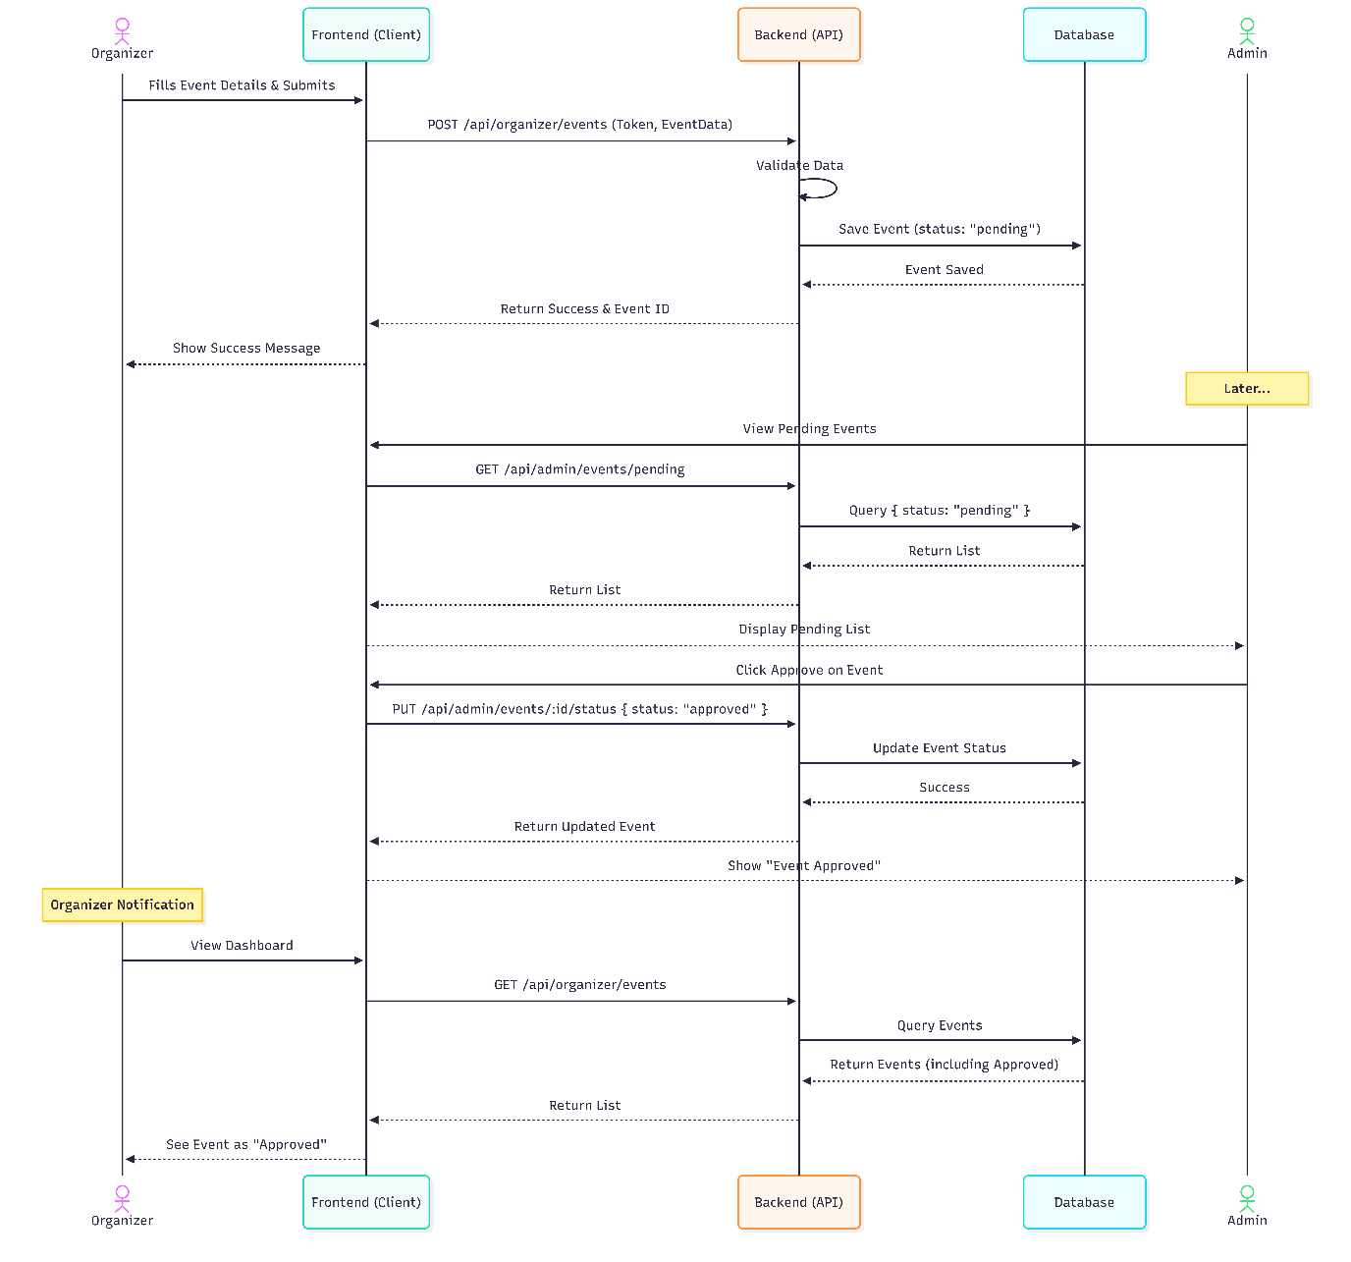

Figure .: Event Creation and Approval

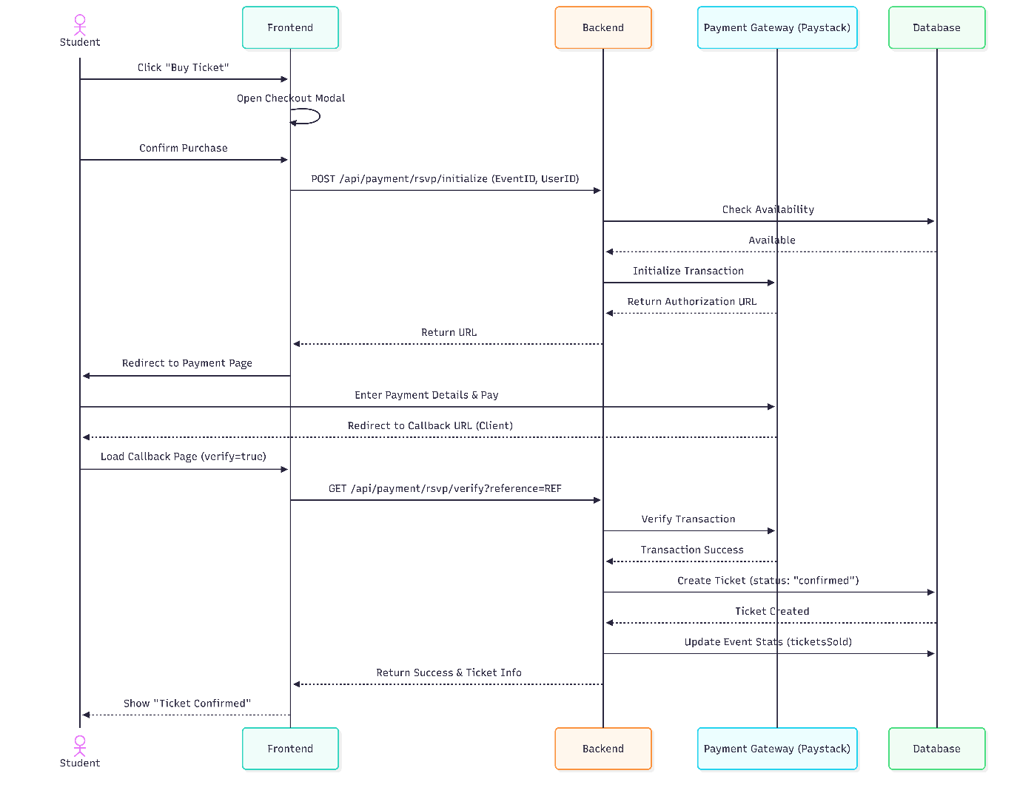

Figure .: Ticket Booking and Payment

### Architectural Design

The Class Diagram here shows the structural integrity of the Campus Event Management and Notification system, which would serve as the static blueprint for the whole application logic. Figure 3.5 presents the architecture that strictly enforces separation of concerns by decoupling the data entities (Models) from the business logic (Controllers).  
The core data models, such as User, Event, and Ticket, lie at the heart of this design and define the shape of the data stored in MongoDB. These do not stand in isolation, however, and each model is managed by an associated logical handler, such as the AdminController and OrganizerController. These controllers wrap the critical methods, like updateEventStatus and createOrganizerEvent, which will validate user inputs and enforce security rules before any data is irreversibly committed. This is done out of modularity; if the decision logic remains inside specific controllers rather than being interwoven inside the database schema, it improves the scalability and makes the system easier to debug upon future updates.

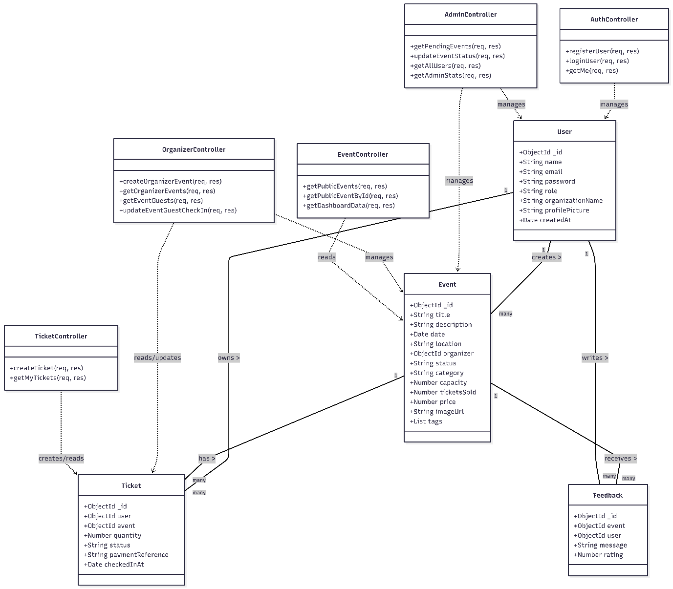

Figure .: Architectural Diagram

### Database Design

The persistence of data in the Campus Event Management and Notification system is mapped here using an Entity Relationship Diagram that acts as the schematic blueprint to the application's MongoDB database. According to Figure 3.6, the design is cantered around four cardinal entities, namely User, Event, Ticket, and Feedback; all of which are related using respective Foreign Key constraints in order to ensure data consistency.  
The diagram shows how the User entity is the main actor but can also play the role of "student" or "organizer" without needing additional tables. This efficiency extends to the relationships; for example, the Event entity has a foreign key that allows it to refer directly to its organizer but also acts as the parent record for multiple Ticket and Feedback entries. By tightly defining these relationships—such as necessitating that every Ticket refer to a valid event and user—the application layer enforces logical referential integrity and prevents anomalies such as tickets without corresponding events or reviews without verified authors.

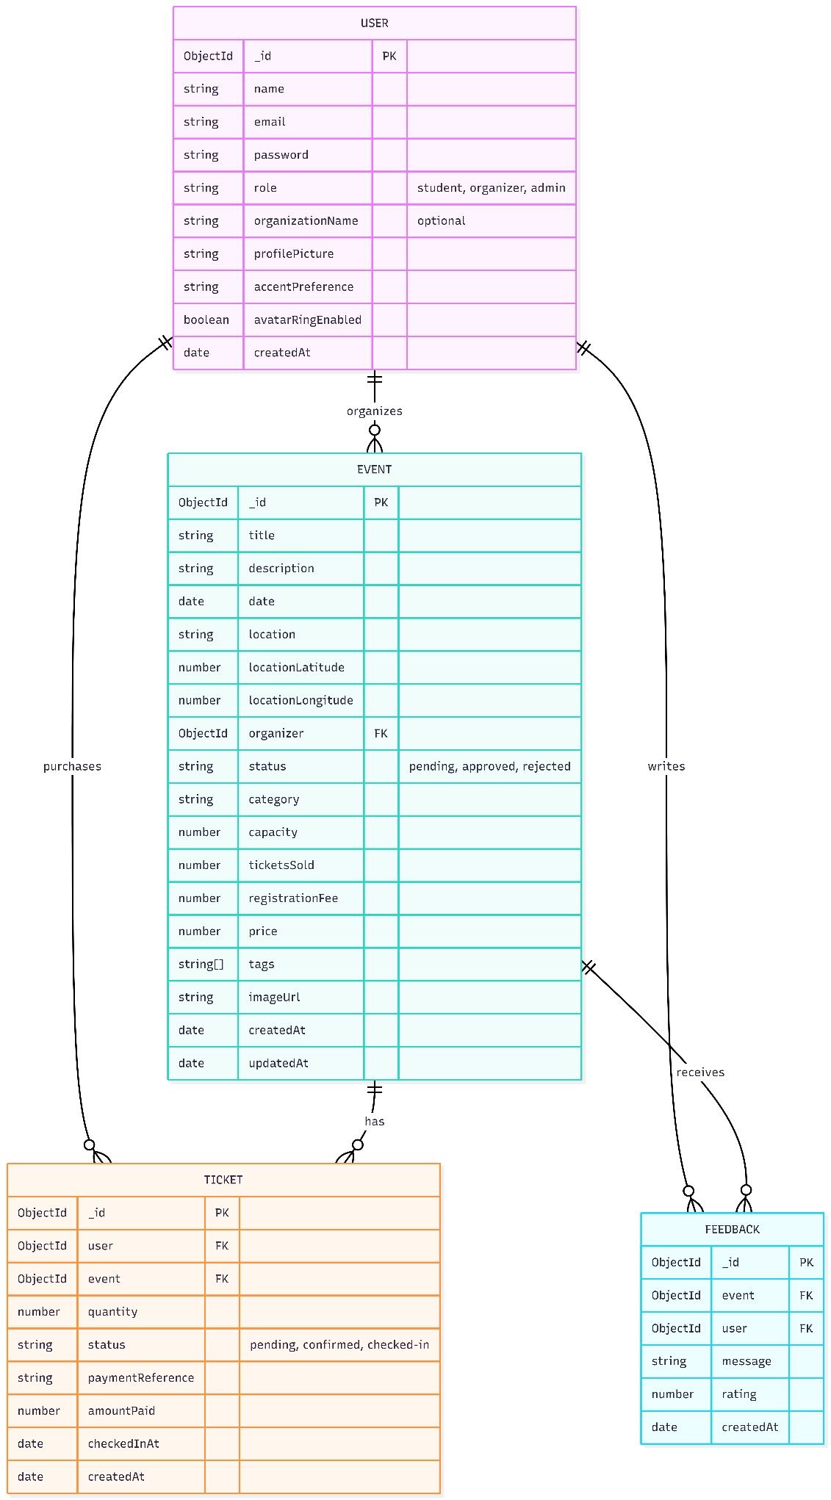

Figure .: Database Diagram

## Summary

This chapter detailed the comprehensive methodology and design strategies employed to develop the Campus Event Management and Notification System. It justified the selection of the Waterfall System Development Life Cycle (SDLC) as the primary development model, citing its suitability for projects with clearly defined requirements and structured phases. Through a rigorous analysis of the existing manual processes at Bayero University Kano and a quantitative stakeholder survey, the chapter established the critical functional and non-functional requirements necessary to solve the current fragmentation issues.

Furthermore, the chapter translated these requirements into technical specifications. This included a detailed requirement analysis using Use Case descriptions and a robust system design phase. The design was visualized through Sequence Diagrams to map operational workflows, Class Diagrams to define the software architecture, and Entity Relationship (ER) Diagrams to structure the MongoDB database. Collectively, these methodological steps provide a verified architectural blueprint, setting the stage for the implementation and testing phases detailed in the subsequent chapter.

# IMPLEMENTATION AND TESTING

## INTRODUCTION

This chapter delineates the practical realization of the Campus Event Management and Notification System, transitioning the project from the architectural design phase detailed in Chapter 3 to the subsequent stages of software construction and validation. It meticulously specifies the development environment, including the programming languages and third-party integrations utilized in the application's construction. Pseudocode algorithms define the operational logic, while detailed interface walkthroughs demonstrate the system's practical limits. The chapter closes on validation. We subjected the system to unit, integration, and usability assessments, confirming it fulfills functional requirements and holds up within the university environment.

## **IMPLEMENTATION**

The construction phase opens by justifying the technology stack, detailing the specific languages and databases engaged to build the solution. The text then isolates the algorithms driving authentication, booking, and payments, utilizing pseudocode to map backend data processing. Interface screenshots close the chapter. These visuals confirm that the deployed software achieves fidelity with the design specifications proposed in Chapter 3.

### Implementation Tools

To create the Campus Event Management and Notification System, a formidable selection of software tools and technologies was necessary. The system was built using the MERN Stack, given the efficiency, scalability, and unified use of JavaScript for both client and server sides. The table below summarizes the specific hardware and software environments employed during the implementation phase.

Table ‑: Summary of Implementation tools

|  |  |  |
| --- | --- | --- |
| Category | Tool / Technology | Justification & Usage |
| Operating System | Windows 11 | The primary development environment used to run local servers and testing tools. |
| Programming Language | JavaScript (ES6+) | The core language used for both frontend interactivity and backend logic. |
| Frontend Framework | React.js (Vite) | Chosen for its component-based architecture and Virtual DOM, ensuring a responsive user interface. |
| Backend Runtime | Node.js & Express.js | Selected for its non-blocking, event-driven architecture to handle concurrent API requests efficiently. |
| Database | MongoDB | A NoSQL database used for its flexible schema (BSON) to store complex event and ticket data. |
| IDE / Code Editor | Visual Studio Code | The integrated development environment used for coding, debugging, and extension support. |
| Web Browser | Google Chrome | Used for rendering the application and utilizing Chrome DevTools for debugging UI issues. |
| API Testing | Postman | Employed to test backend API endpoints (POST, GET, PUT) before integrating them with the frontend. |
| Payment Gateway | Paystack API | Integrated to process secure payments and verify transaction references for paid events. |
| Version Control | Git & GitHub | Used to track code history, manage feature branches, and maintain off-site backups. |

According to Table 4.1, the system was implemented on top of the MERN Stack-MongoDB, Express, React, Node.js, driven by the necessity of a common programming language, namely JavaScript ES6+, throughout the application. This unified approach enabled smooth data synchronization across both the client and server. The development process was conducted within the Windows 11 environment using Visual Studio Code as the main editor, due to its robust capabilities in handling JavaScript debugging and syntax highlighting.

With React.js, powered by the Vite build tool, the UI achieved a dynamic "Single Page Application" feel, whereby features such as the Event Dashboard seamlessly update content on the fly without full page reloads. On the server side, Node.js and Express.js proved to be a very capable non-blocking runtime, handling high volumes of activity-., eg, several simultaneous RSVPs to the same event-without any latency. On the data persistence layer, MongoDB was selected due to its flexible BSON document structure, capable of easily housing nested data common in events, such as storing a list of attendees inside an event object.

Extensive testing, using Postman, was done to ensure system reliability by independently verifying API endpoints from the frontend. Google Chrome DevTools were used extensively to hone in on the responsiveness of the UI at various screen sizes. Finally, integrations with external services were done securely: financial transactions were managed through an implementation of the Paystack API, and all code changes throughout the project lifecycle were versioned and backed up securely using Git and GitHub.

### Algorithms of major functionality

This section describes the algorithmic logic behind the system's primary functions. The algorithms that are used to describe the backend processes for authentication, event booking, payment verification, and the recommendation engine are presented in high-level pseudocode to allow the reader to visualize logical flow independent of specific syntax.

#### Search and Browse Events

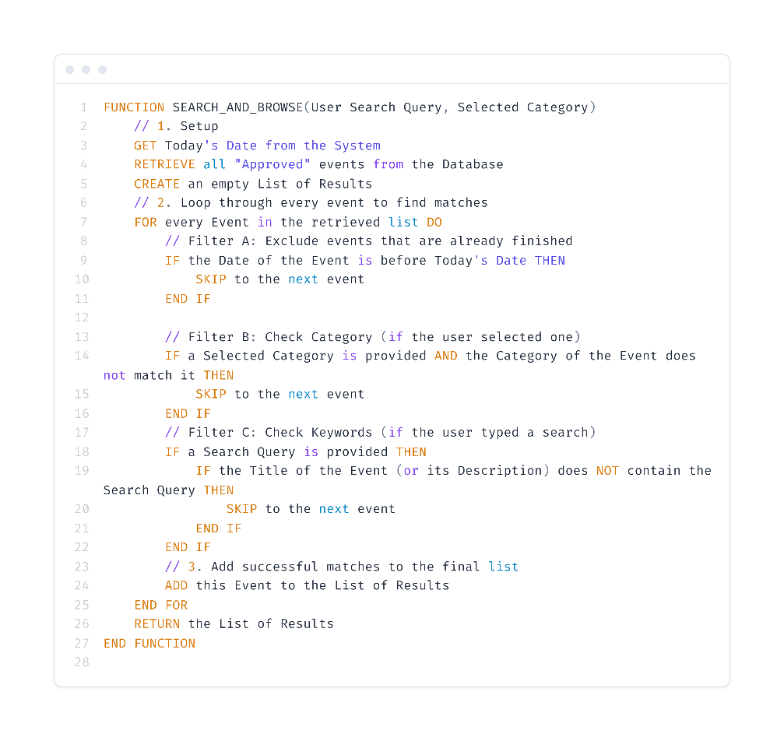

Figure .: Search and Browse Event Algorithm

As shown in **Figure 4.1**, the Search and Browse algorithm details the logic for retrieving approved events and applying user-selected filters.

#### RSVP for event

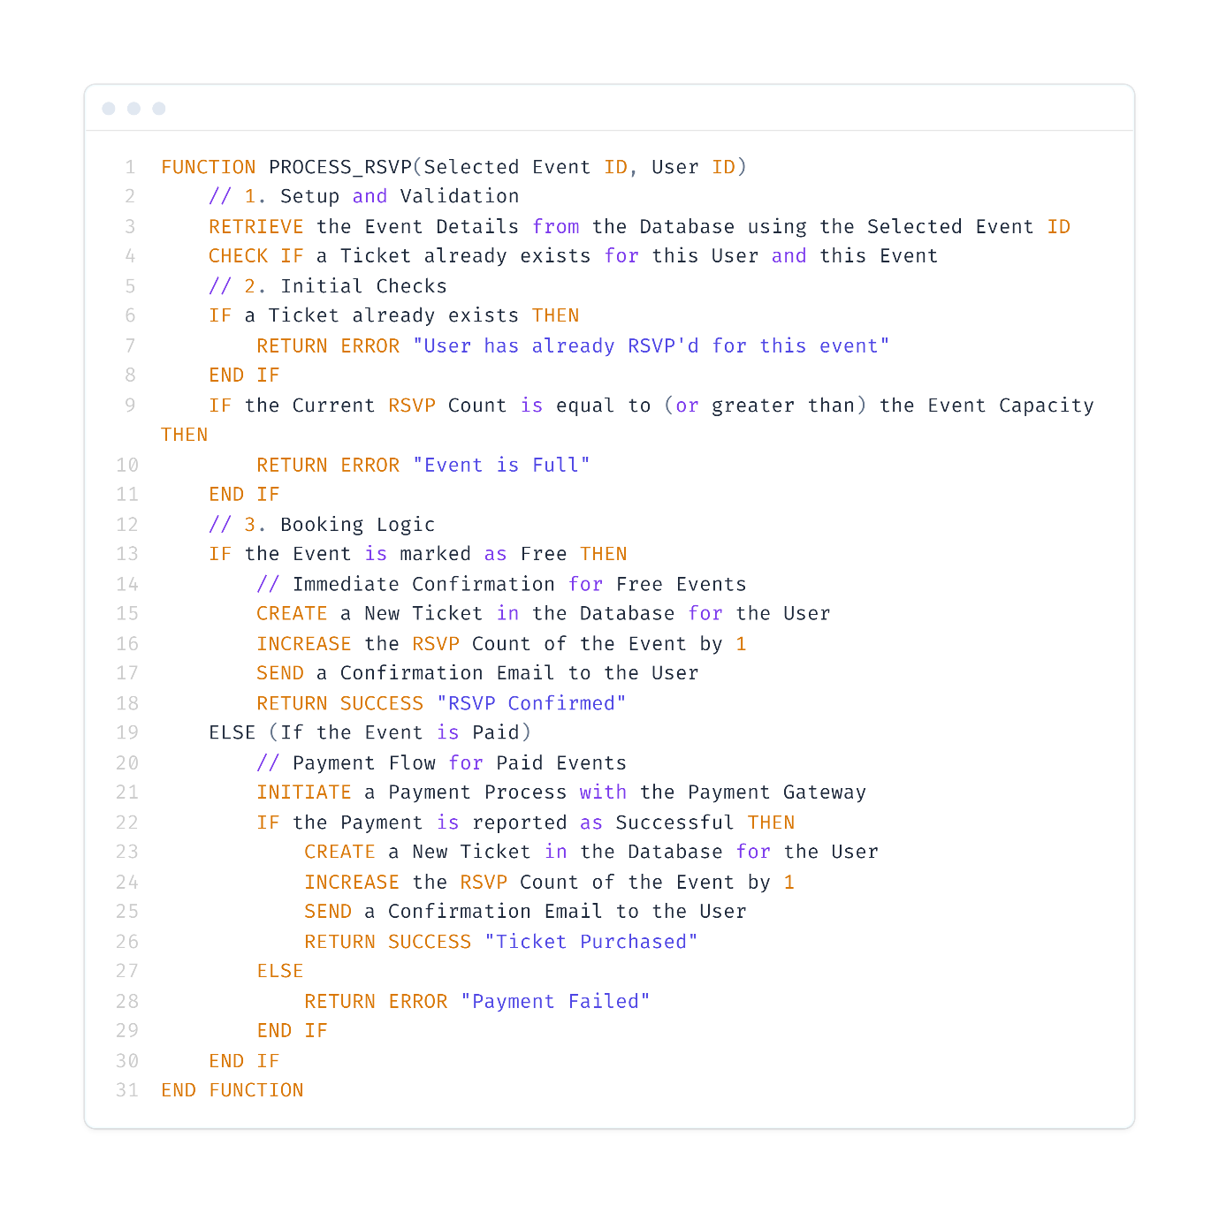

Figure .: RSVP for event Algorithm

As illustrated in Figure 4.2, the RSVP algorithm orchestrates the complete booking process by rigorously validating seat availability and checking for duplicate entries before routing the user to either instant ticket generation or the secure payment gateway.

#### Submit Feedback

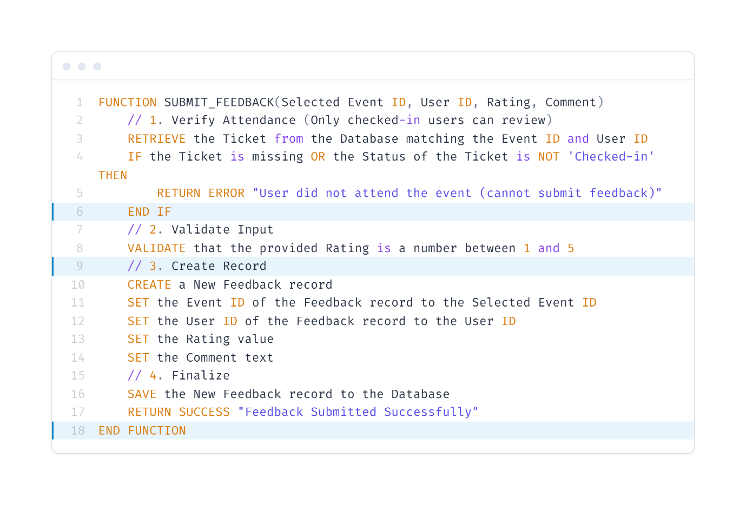

Figure .: Submit Feedback

As illustrated in Figure 4.3, the Feedback submission process governs post-event engagement by verifying the user's attendance status and sanitizing textual input before committing the review and rating to the centralized database.

* + - 1. Create Event  
         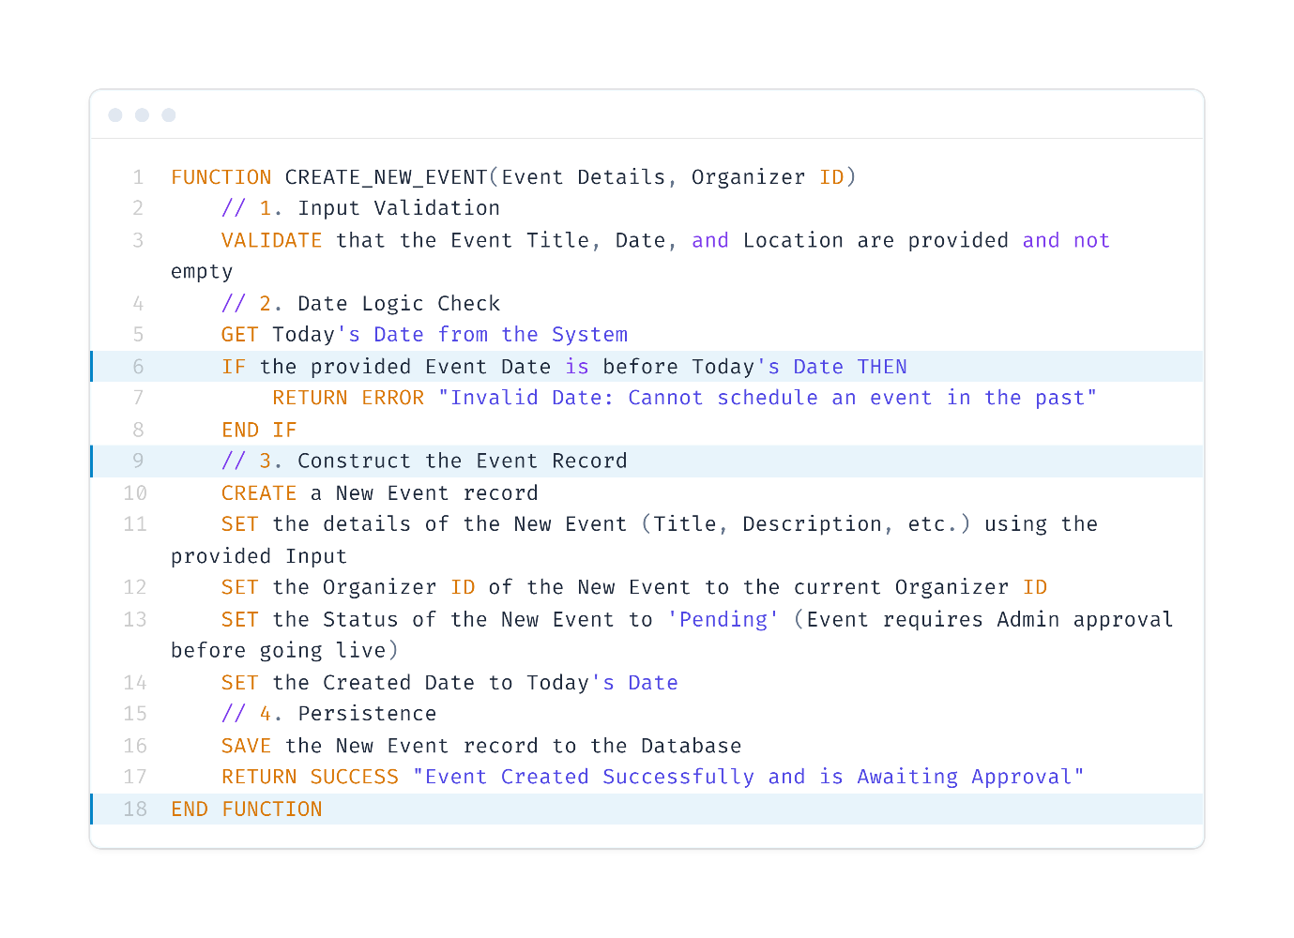

Figure .: New Event Creation Algorithm

As illustrated in Figure 4.4, the New Event Creation algorithm orchestrates the scheduling workflow by rigorously validating organizer inputs and performing conflict detection against existing bookings before committing the event details to the centralized database.

* + - 1. Emergency Update  
         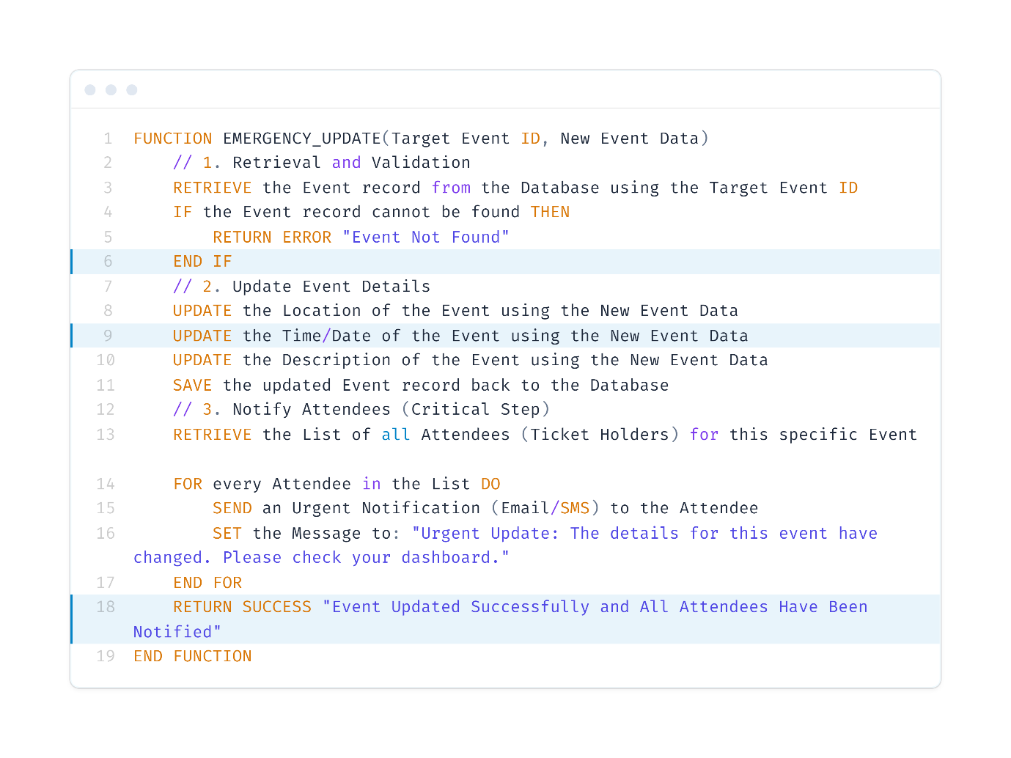

Figure .: Event Update Algorithm

As illustrated in Figure 4.5, the Event Update algorithm manages modifications to existing schedules by re-validating venue availability against new time constraints before committing the changes and triggering automated notifications to registered attendees.

#### Guest Check In

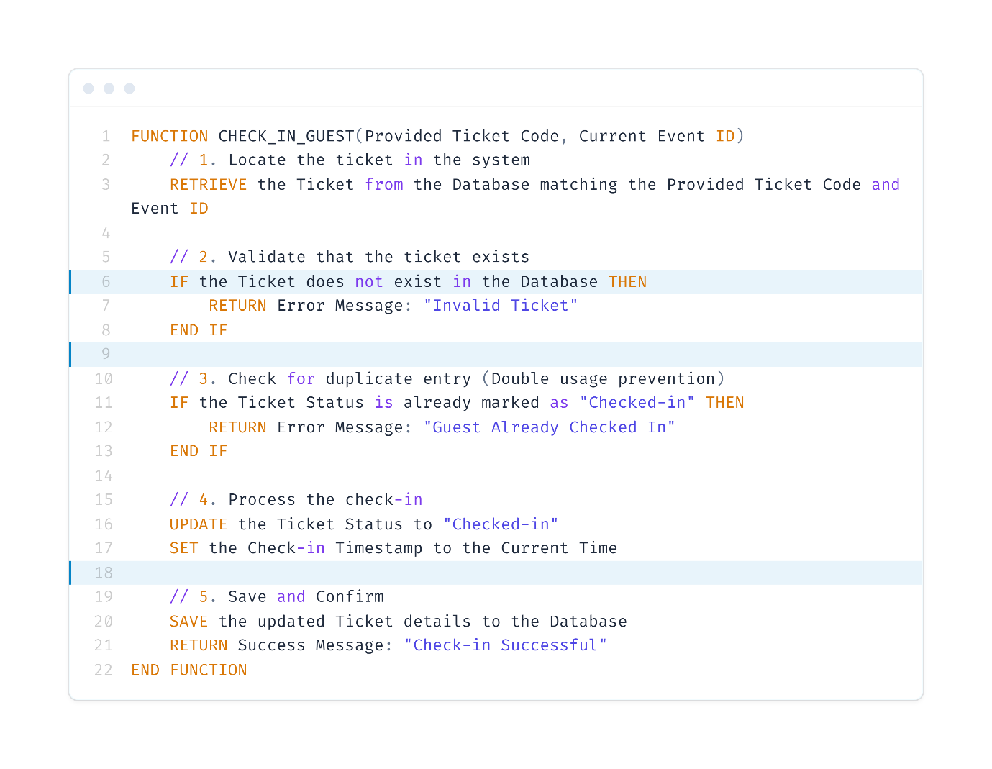

Figure .: Guest check in Algorithm

As illustrated in Figure 4.6, the Guest Check-in algorithm secures the entry process by rigorously validating ticket authenticity and detecting duplicate usage attempts before timestamping the attendee's arrival.

* + - 1. Approve / Reject Event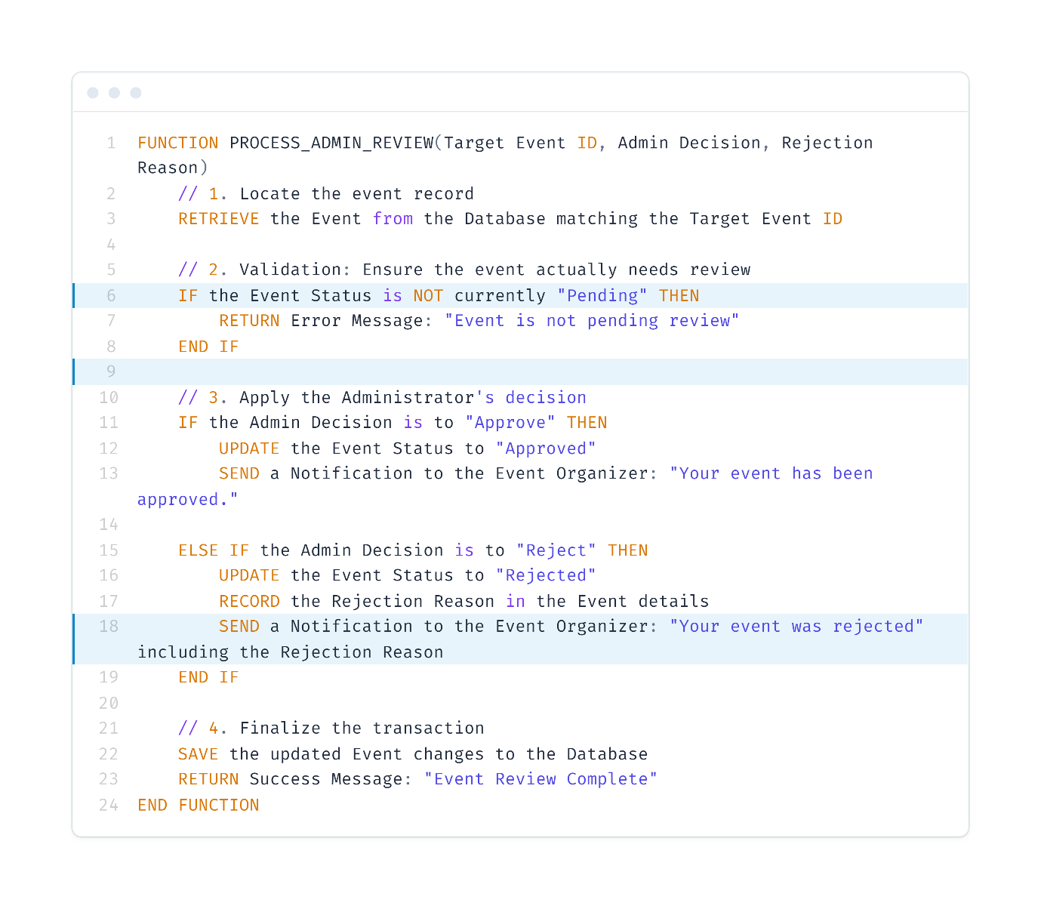

Figure .: Approve / Event Algorithm

As illustrated in Figure 4.7, the Event Review algorithm orchestrates the moderation workflow by validating the pending status of a submission before processing the administrator's decision to either publish the event or trigger a rejection notification.

#### Manage Users

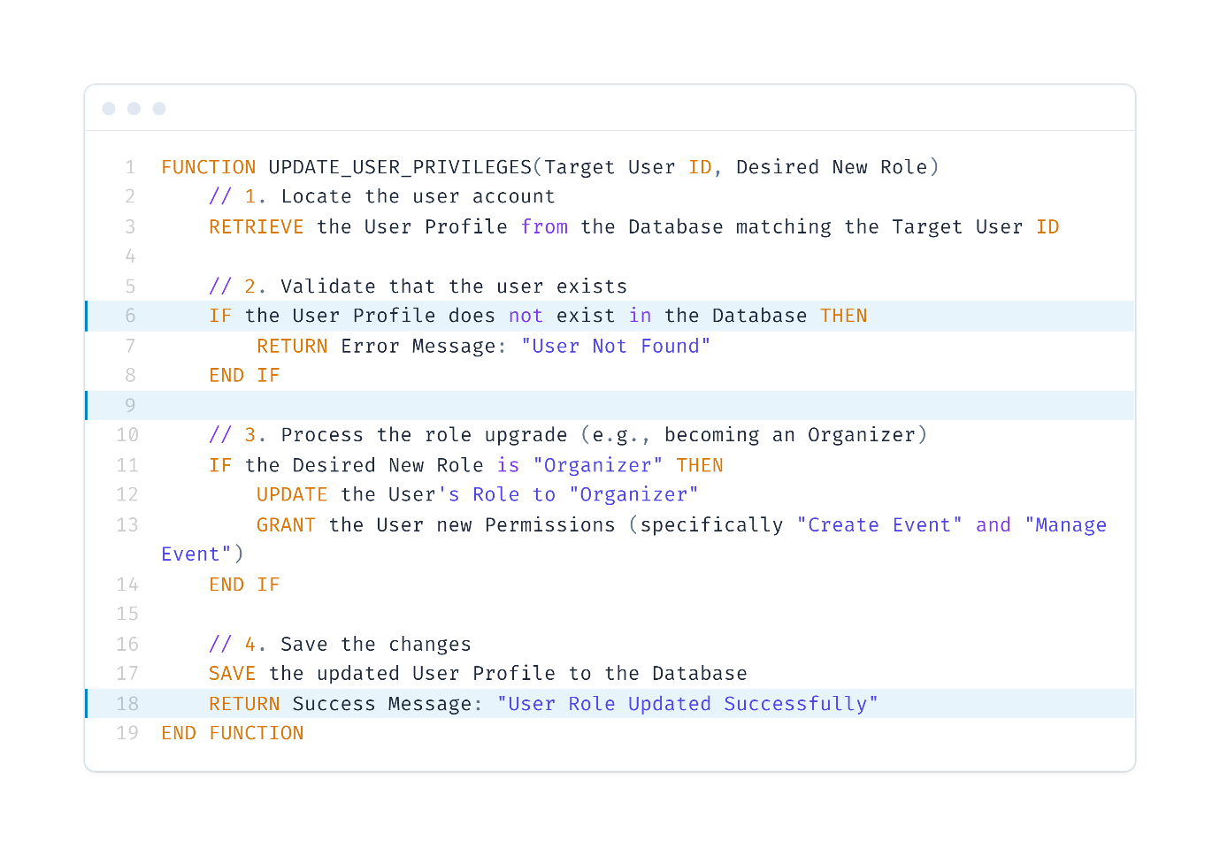

Figure .: Manage Users Algorithm

As illustrated in Figure 4.8, the Manage Users algorithm orchestrates the administration of account privileges by validating user identities before applying role upgrades and expanding access permissions in the system.

### Description of System Operation

Section 4.2.3 describes the GUI of the developed Campus Event Management System. The section provides an overview of what the system's primary modules look like and how the theoretical design requirements are converted into a functional application. The following screenshots depict the actual look and feel of the system as experienced by the end-users.

Figure 4.9 illustrates the Login Interface, which serves as the secure gateway for all user roles (Students, Organizers, and Administrators). The design prioritizes simplicity and security, featuring input fields for the user's institutional email and password.

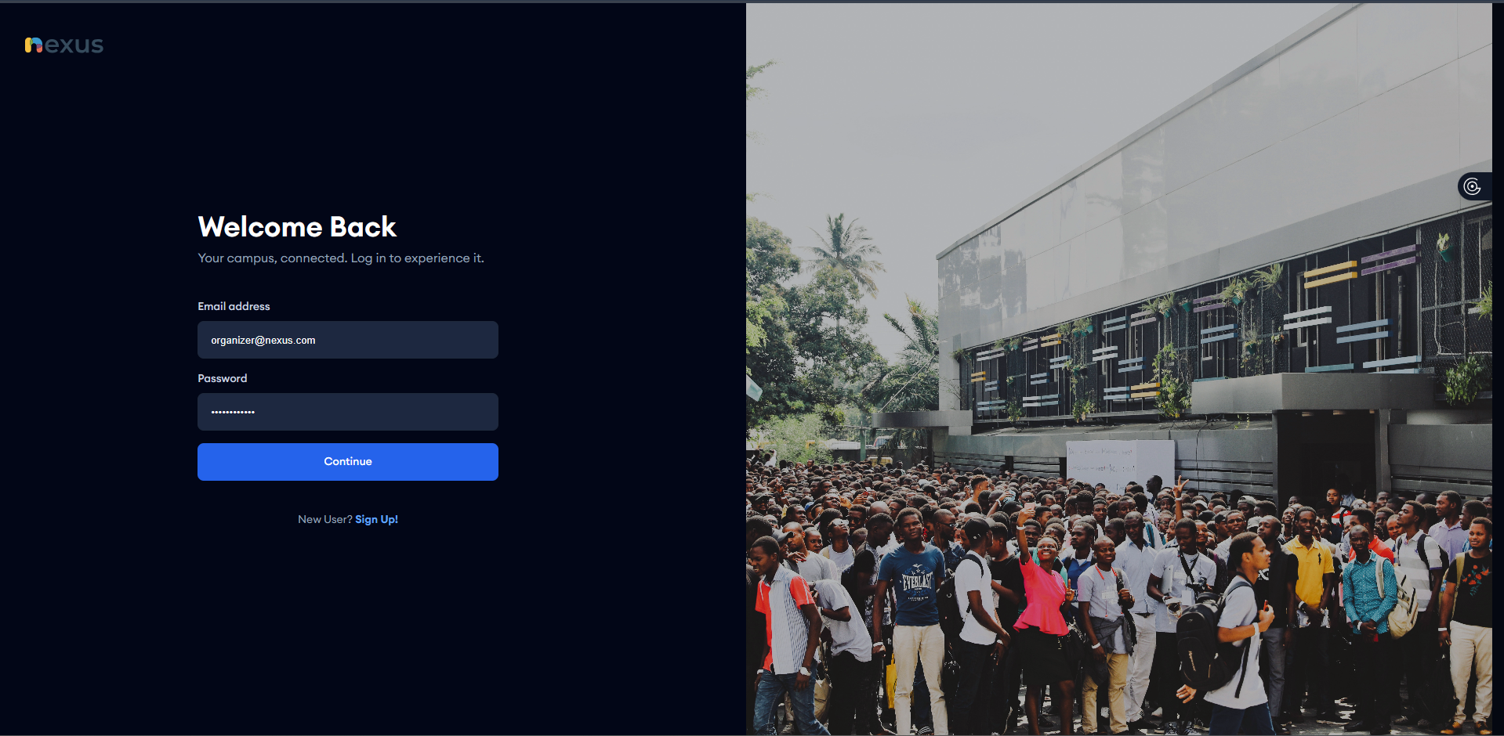

Figure .: Log In Interface

Guest Registration Interface Figure 4.10 displays the Guest Sign-Up Form, designed for students and general attendees. This interface captures the essential identity information required for ticket booking, specifically Full Name, Email, and Password. The system employs real-time validation on this screen; for instance, the "Confirm Password" field (visible in the screenshot) must match the primary password exactly. If there is a mismatch, the "Sign Up" button remains disabled, preventing the submission of erroneous data to the server.

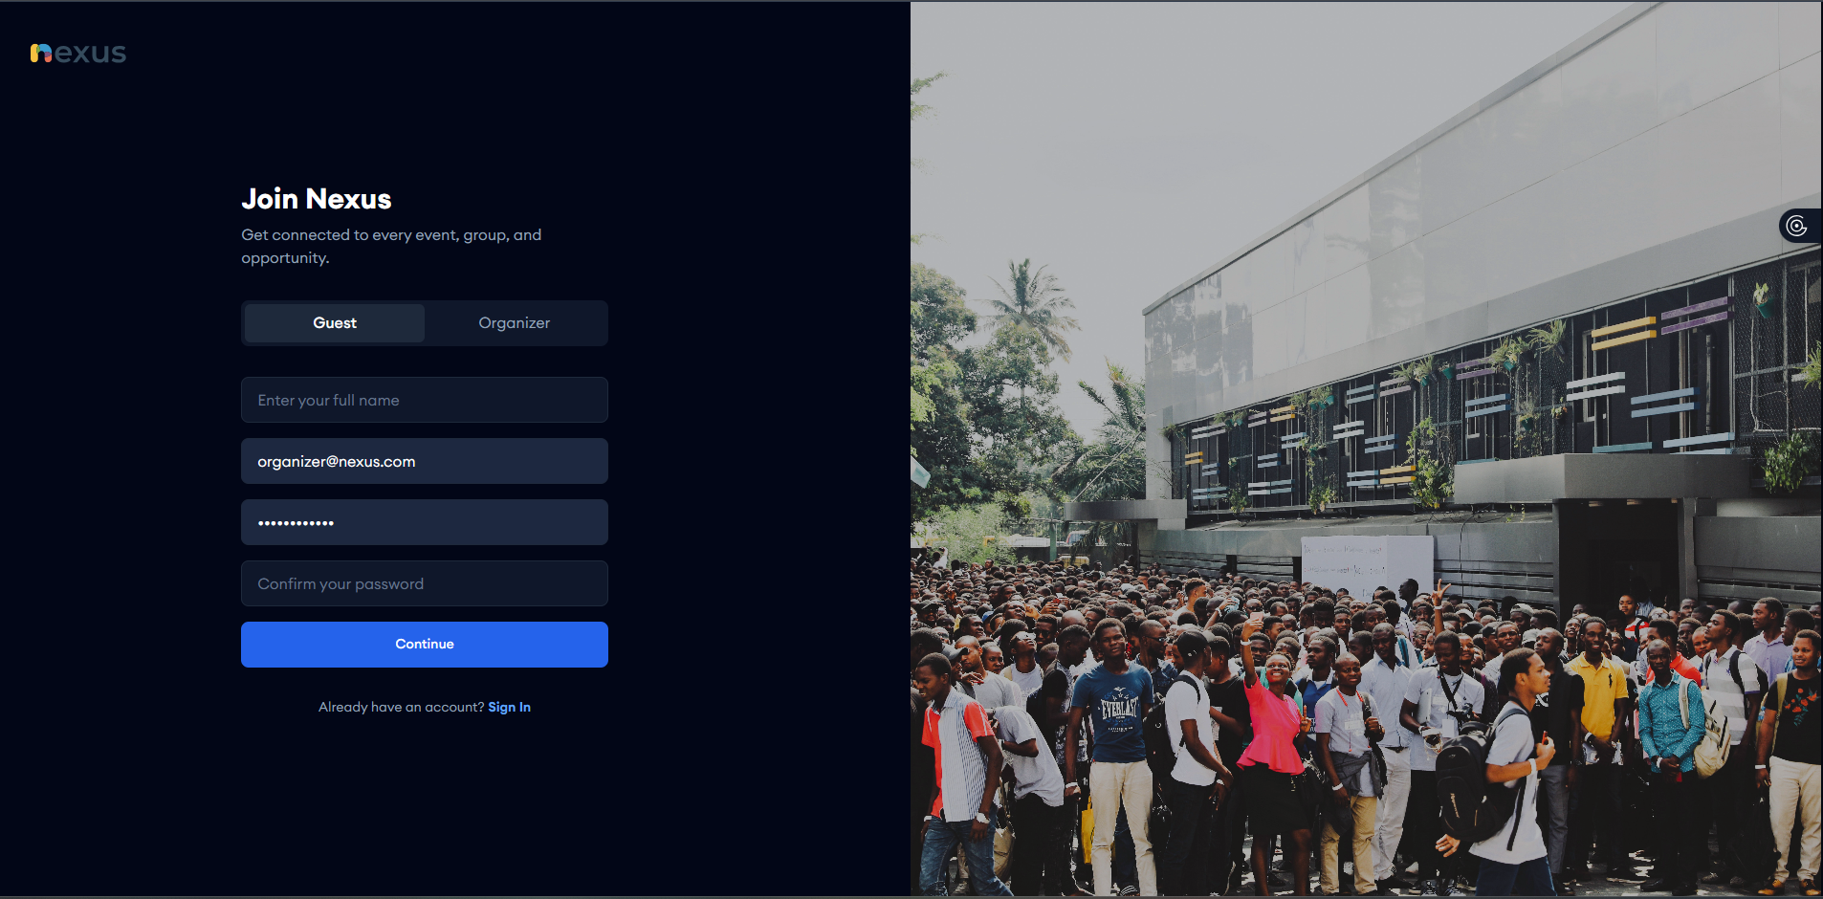

Figure .: Guest Registration Interface

Organizer Registration Interface Figure 4.11 illustrates the specialized Organizer Sign-Up Form. While it shares the core security fields with the guest interface, it includes a mandatory additional field: Organization Name. This input is critical for the system's architecture.

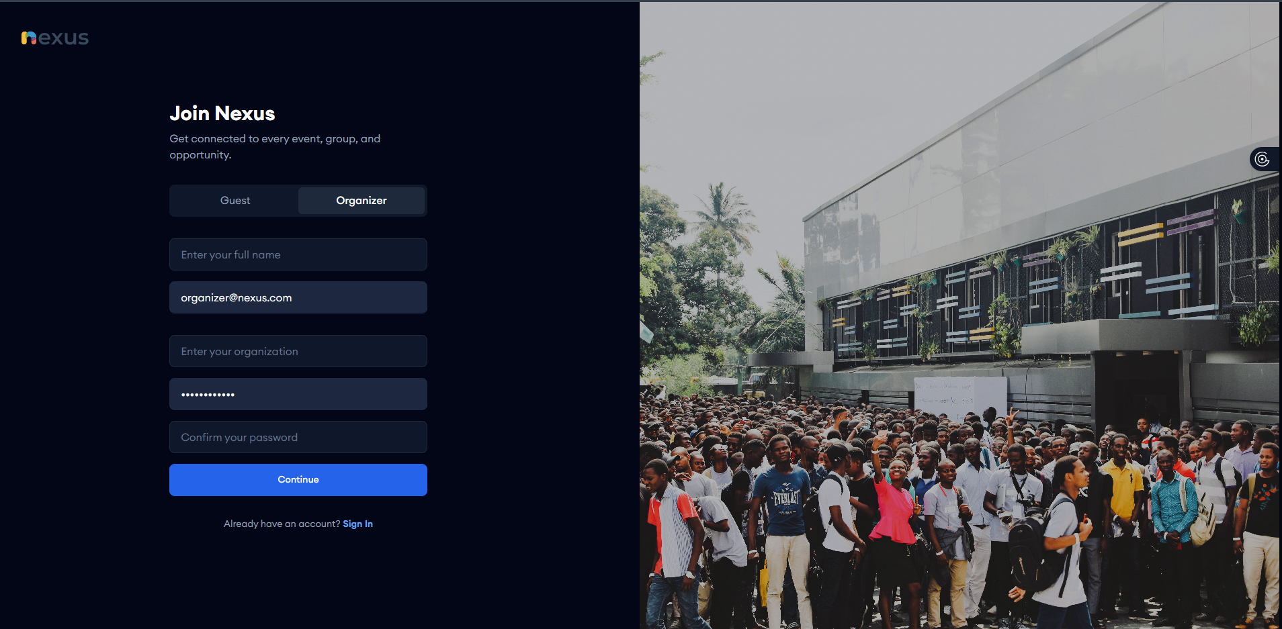

Figure .: Organizer Registration Interface

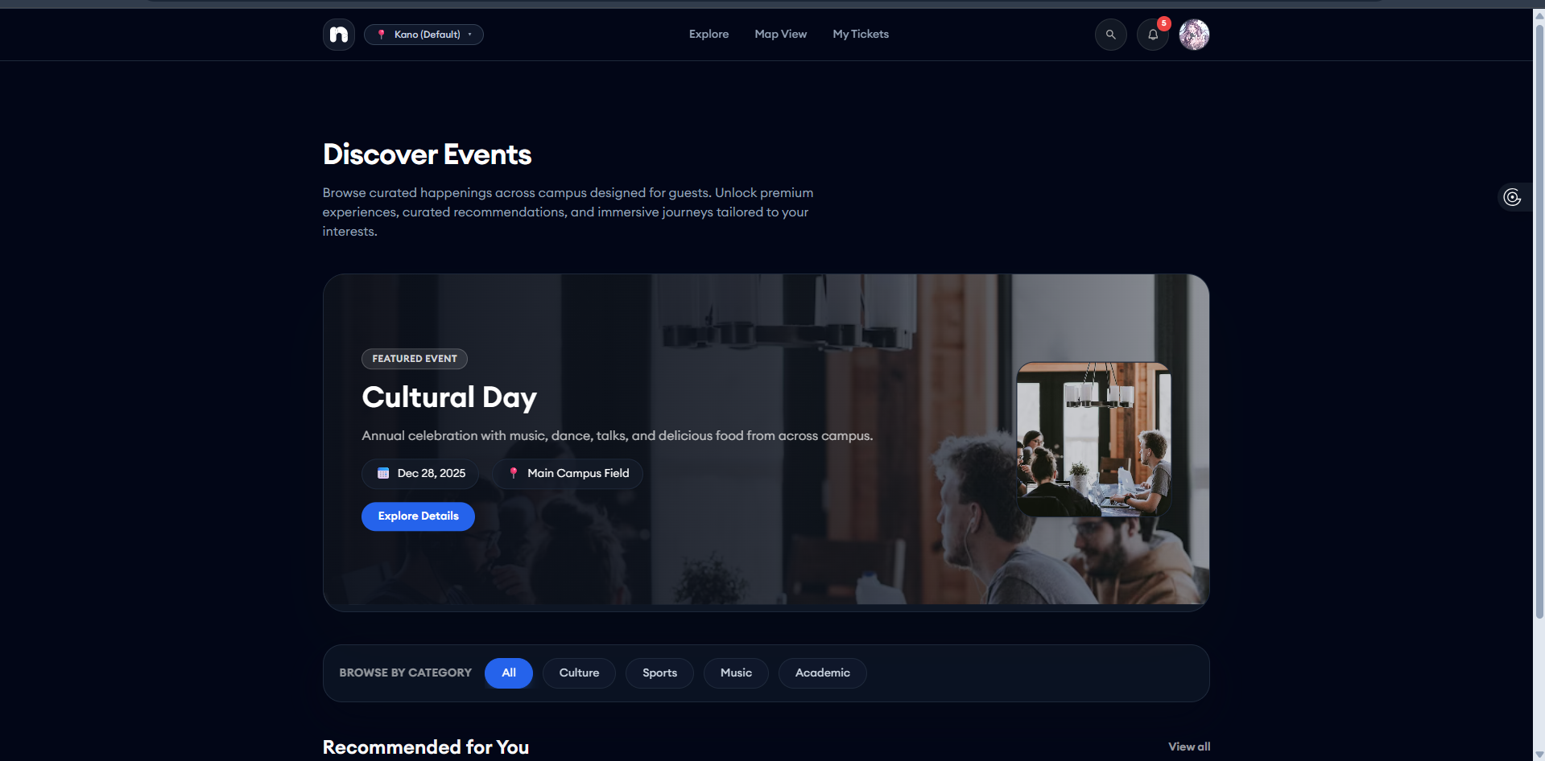

Figure .: Guest Dashboard Interface

Figure 4.11 illustrates the Guest Dashboard, which serves as the central hub for student engagement. This interface is dynamically populated using the Recommendation Engine Algorithm (detailed in Section 4.2.2), ensuring that each student sees content relevant to their interests.

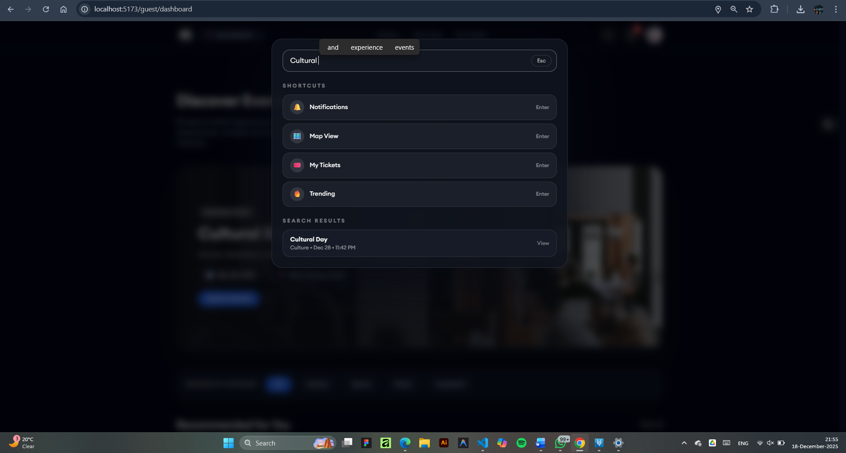

*Fig 4.13 Global Search*

Figure 4.13 shows the Global Search Modal, which is intended to be one-stop tooling for improving navigation and accessibility for users. In contrast to a normal search bar, this “Command Palette” overlay lets the user search the entire system for events, categories, and navigation shortcuts from any page without having to lose context.

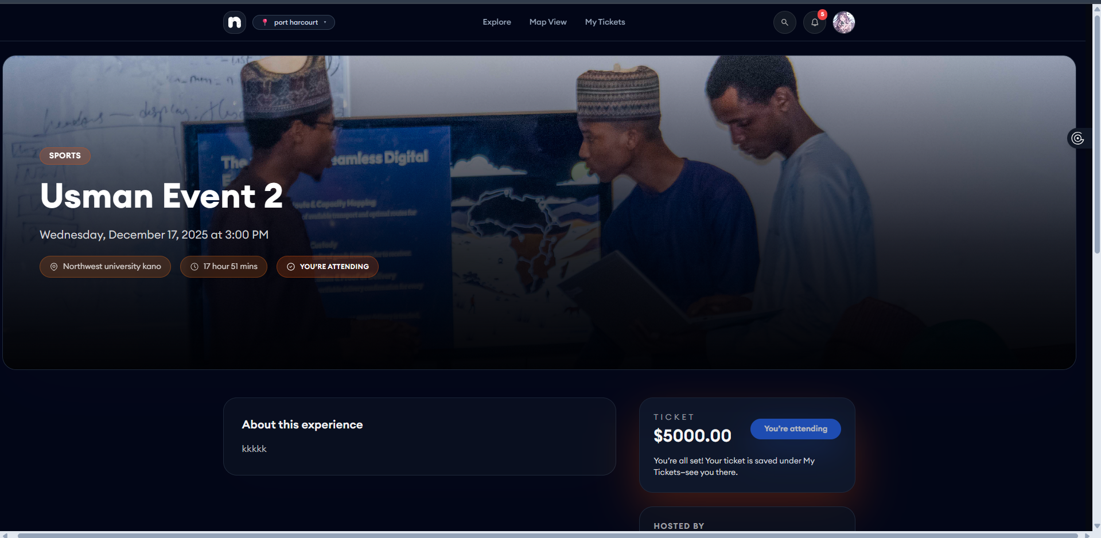

*Fig 4.14 Event Details and Booking Status Interface*

Figure 4.14 depicts the Event Details Interface, which serves as the decision-making point for users. This page aggregates all critical metadata stored in the database including the event banner, location coordinates, date, and ticket pricing (N5000.00) into a unified view.

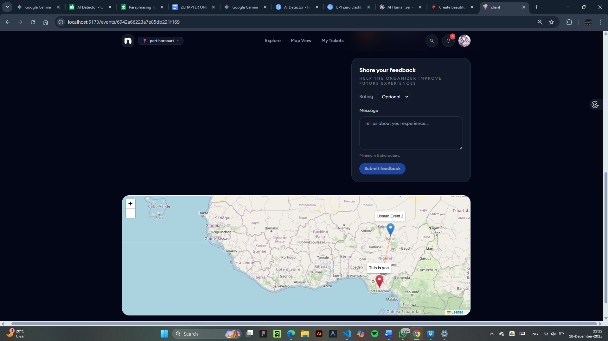

*Fig 4.15 Post-Event Feedback and Geolocation Interface*

Figure 4.15 presents the Feedback and Location Visualization Interface, a dual-purpose screen designed to enhance user engagement after ticket purchase.

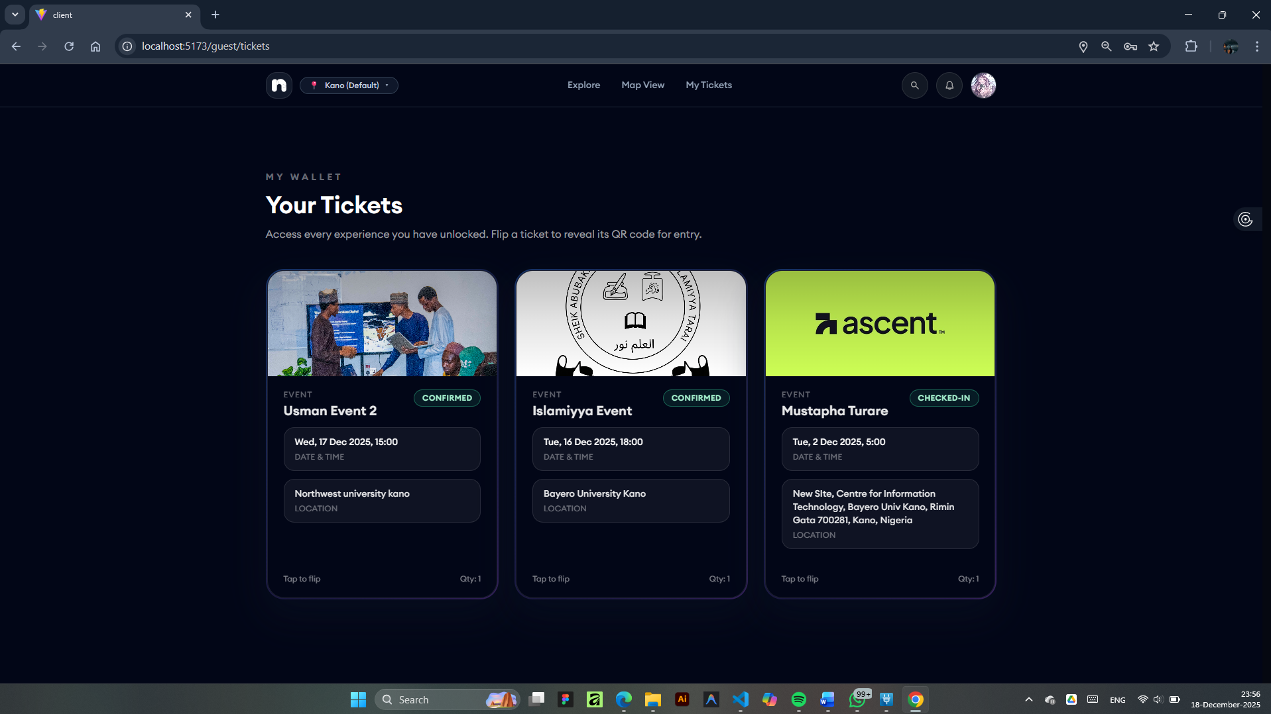

*Figure 4.16 Guest Ticket page*

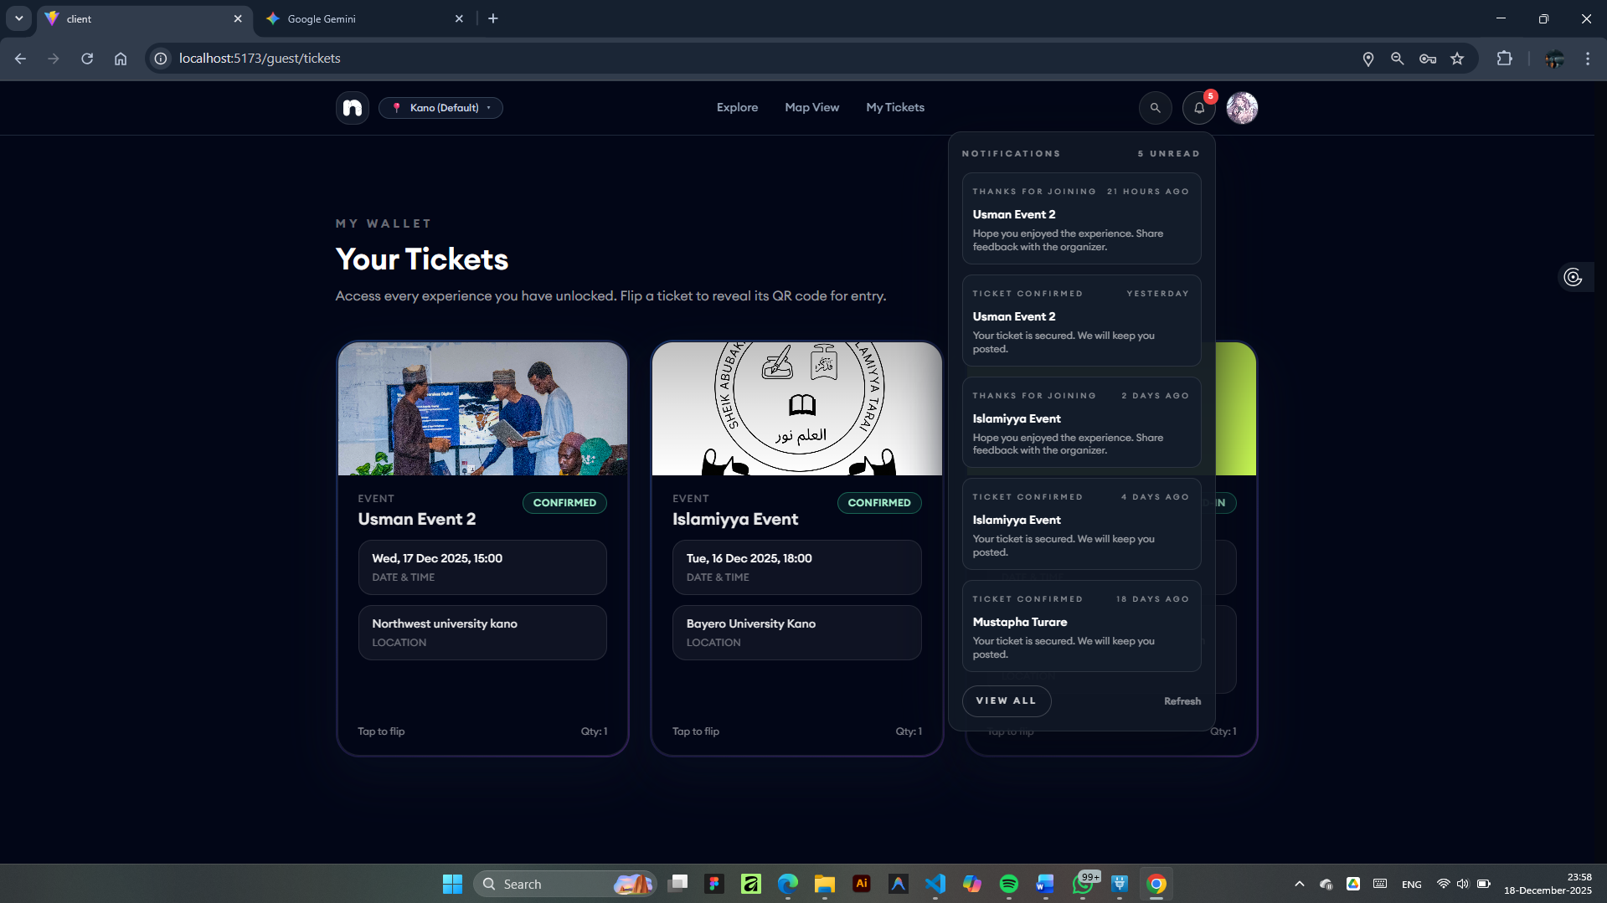

*Figure 4.17 Notification Popdown*

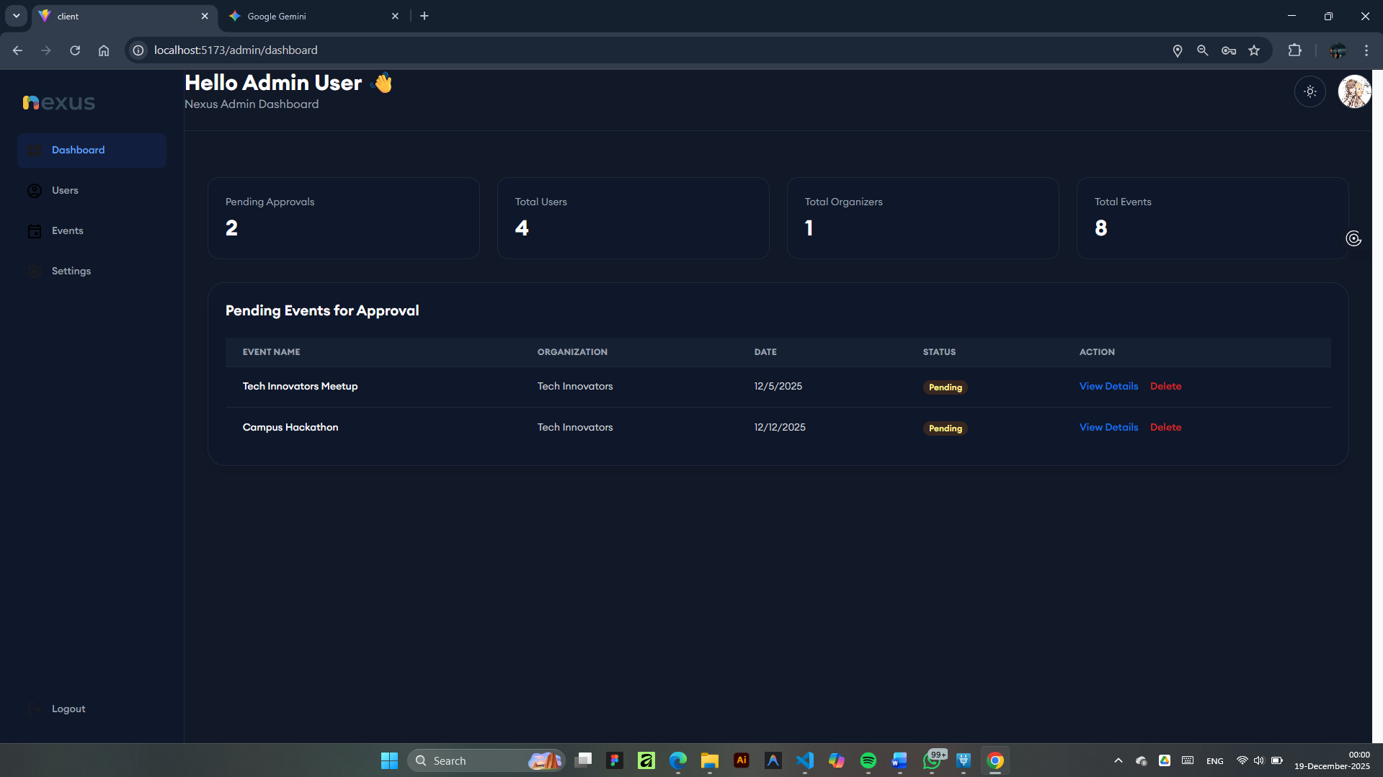

*Figure 4.18 Admin Dashboard*

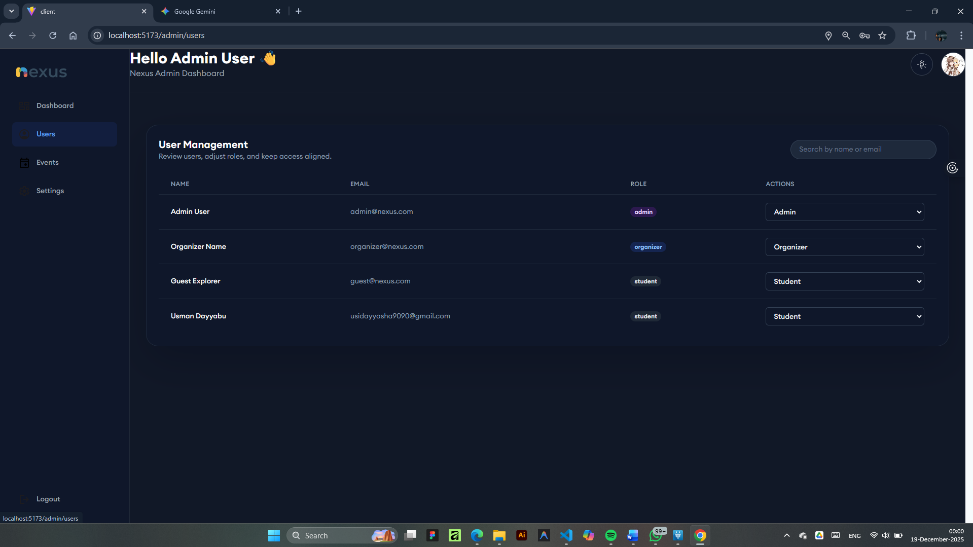

*Figure 4.19 Admin User Management Page*

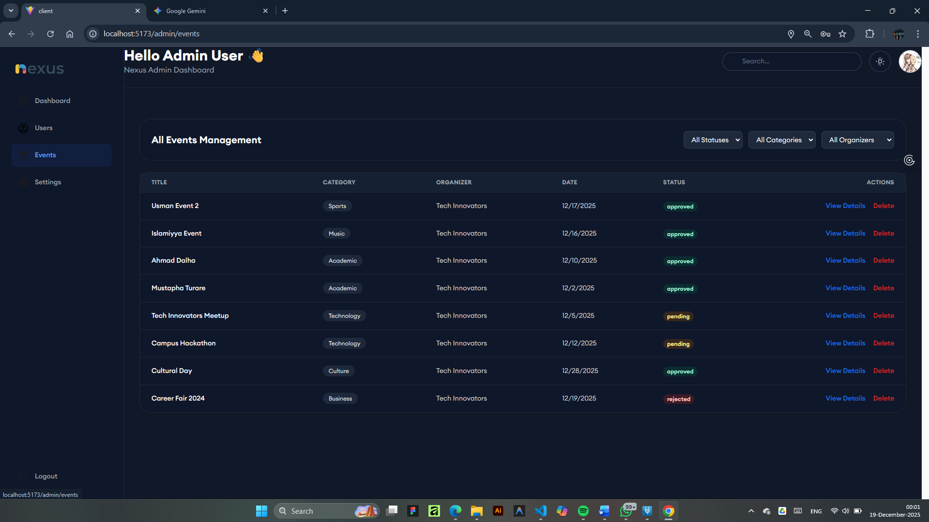

*Figure 4.20 Admin Event Management Page*

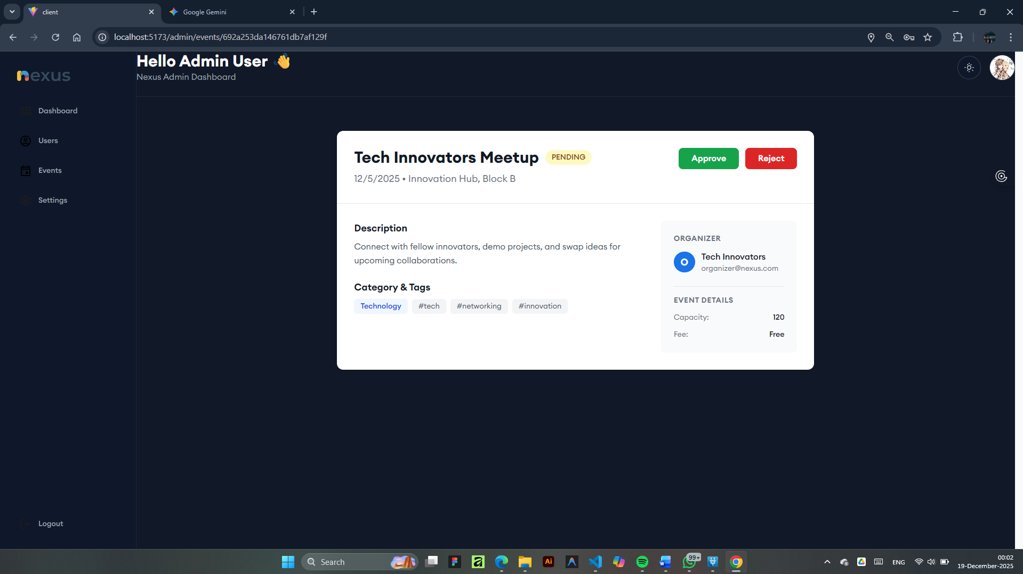

*Figure 4.21 Admin Approve/Reject Event Page*

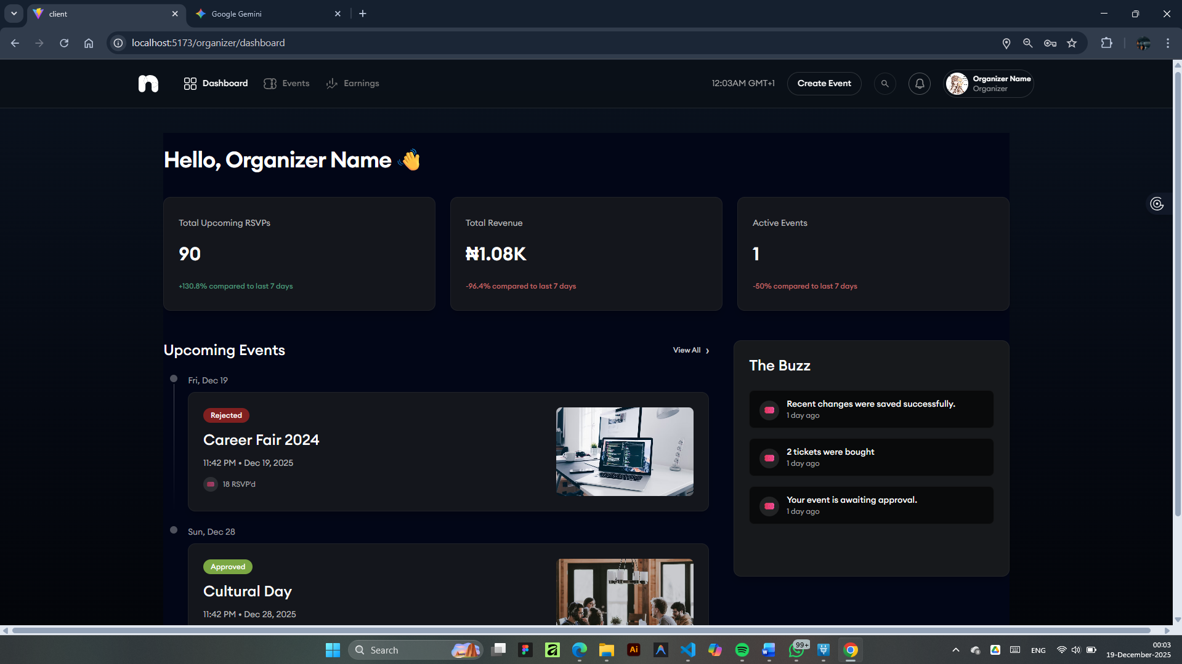

*Figure 4.22 Organizer Dashboard Page*

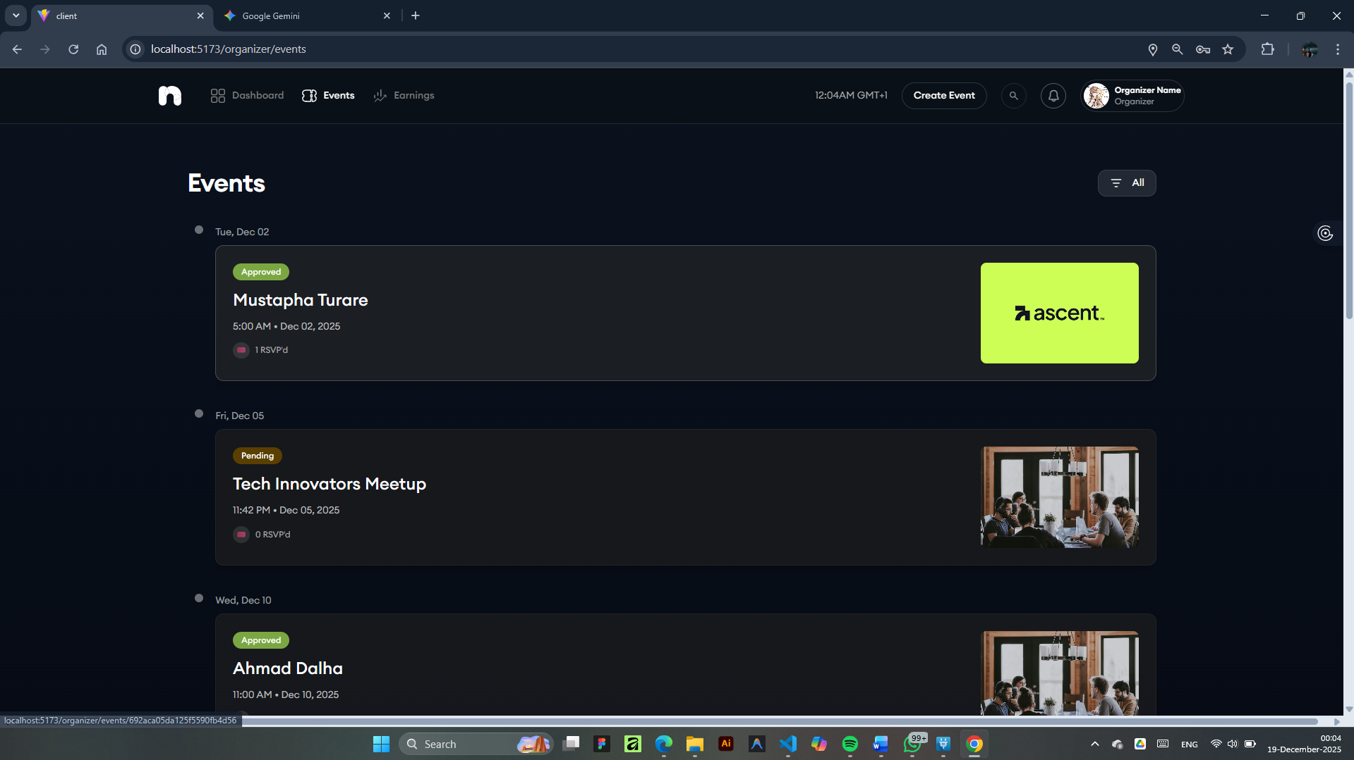

*Figure 4.23 Organizer Event Page*

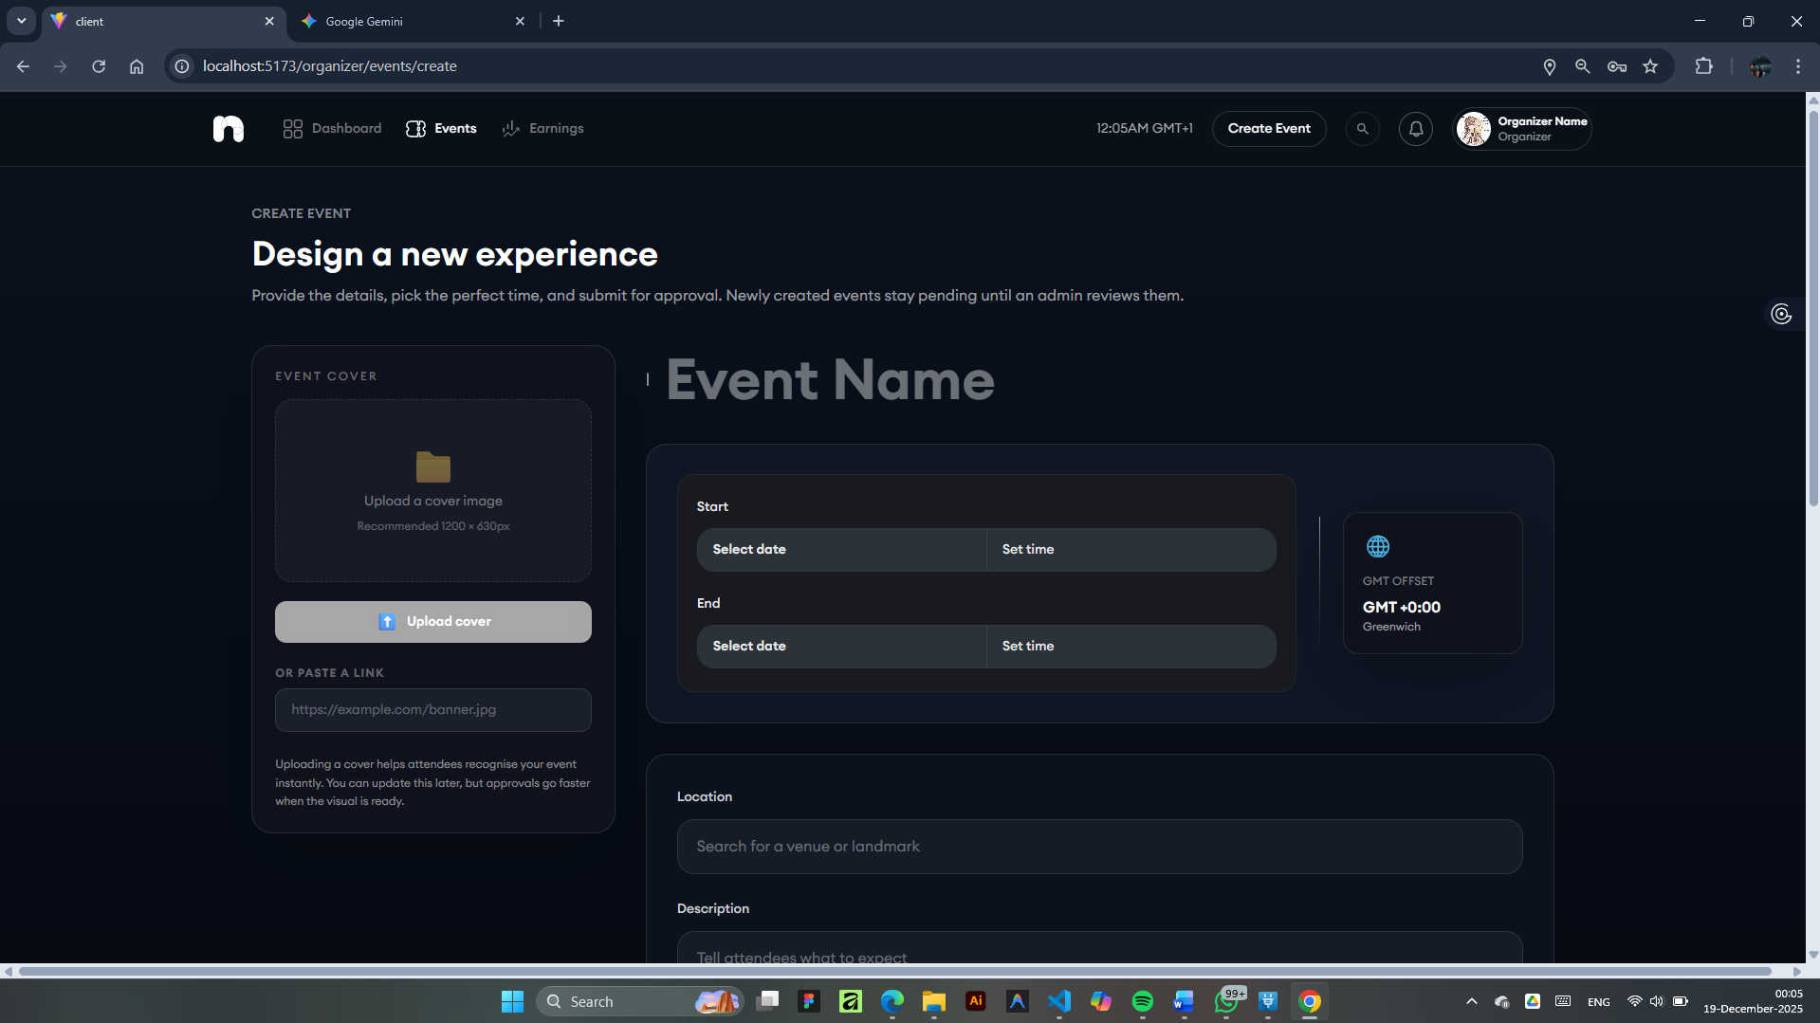

*Figure 4.24 Organizer Create Event Page*

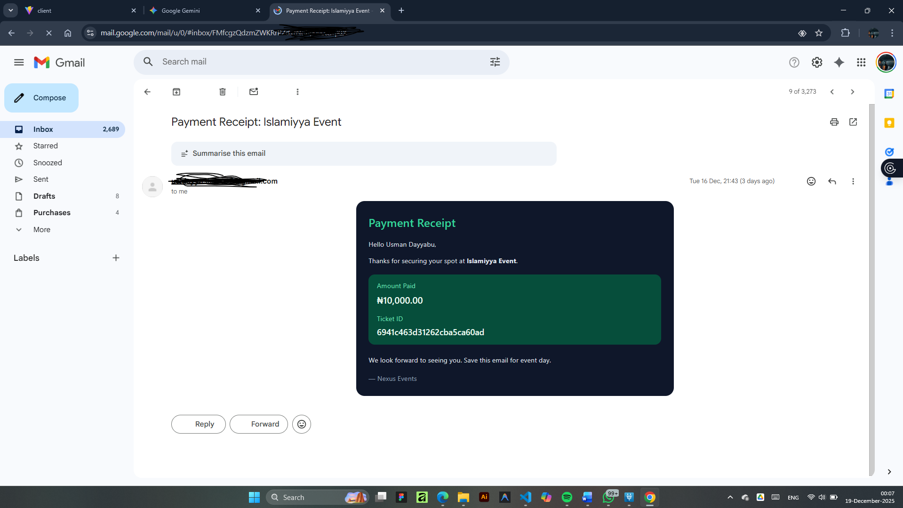

*Figure 4.25 Notification email sample using nodemailer*

* 1. System Testing

System testing will be an important phase of the Software Development Lifecycle to ascertain whether the "Campus Event System" meets all the requirements-functional and non-functional-as identified in Chapter 3. The testing strategy for this project is bottom-up, starting with individual components and integrating them to make a complete system. This way, any errors can be detected and resolved at the earliest possible stage for a robust and reliable final product.

### Unit Testing

Unit testing is the process of checking the smallest portions of an application that can be logically tested, including but not limited to functions, methods, and modules, in isolation. The primary objective is to ensure each unit of the software performs as designed.

The following table presents the unit test cases executed to verify the functionality of individual modules within the Campus Event Management System.

Table ‑: Unit test cases

|  |  |  |  |  |  |  |
| --- | --- | --- | --- | --- | --- | --- |
| **Test ID** | **Module** | **Test Description** | **Test Data / Input** | **Expected Result** | **Actual Result** | **Status** |
| **UTC-01** | Authentication | Login with valid Student credentials. | email: "student@nexus.ac.za"password: "Password123!" | System authenticates the user, generates a JWT token, and redirects to the Student Dashboard. | As Expected | Pass |
| **UTC-02** | Authentication | Login with an incorrect password. | email: "student@nexus.ac.za"password: "WrongPassword" | System rejects the login request and displays an "Invalid credentials" error message. | As Expected | Pass |
| **UTC-03** | Authentication | Login with an unregistered email address. | email: "unknown@nexus.ac.za"password: "Password123!" | System rejects the login request and displays a "User not found" error message. | As Expected | Pass |
| **UTC-04** | Event Management | Organizer creates an event with valid data. | title: "Campus Hackathon"date: "2025-06-15"location: "Engineering Hall" | Event is successfully created in the database and a success message is displayed to the Organizer. | As Expected | Pass |
| **UTC-05** | Event Management | Organizer tries to create an event with a past date. | title: "Past Gala"date: "2020-01-01"location: "Main Hall" | System validation prevents creation and displays a "Date must be in the future" error message. | As Expected | Pass |
| **UTC-06** | Event Management | Organizer tries to create an event leaving the Location field empty. | title: "No Location Event"location: "" | System validation prevents creation and highlights the Location field as required. | As Expected | Pass |
| **UTC-07** | Event Management | Organizer updates an existing event's time (Emergency Update). | eventId: "EVT-001"updateTime: "14:00" (Original: "10:00") | Event time is updated in the database, and registered guests receive an email notification. | As Expected | Pass |
| **UTC-08** | Search & Discovery | Student searches for events using a keyword. | keyword: "Tech" | System retrieves and displays a list of events containing "Tech" in the title or description. | As Expected | Pass |
| **UTC-09** | Search & Discovery | Student filters events by Category. | category: "Social" | System filters the event list to display only events categorized as "Social". | As Expected | Pass |
| **UTC-10** | Booking & RSVP | Student RSVPs for a Free event (Instant confirmation). | eventId: "EVT-100" (Type: Free)userId: "USR-001" | System registers the user, decrements available seats, and sends a confirmation email. | As Expected | Pass |
| **UTC-11** | Booking & RSVP | Student attempts to RSVP for a Sold Out event (Capacity check). | eventId: "EVT-FULL"(Capacity: 50, RSVP: 50) | System prevents the RSVP action and displays an "Event Sold Out" message. | As Expected | Pass |
| **UTC-12** | Booking & RSVP | Student attempts to RSVP twice for the same event (Duplicate check). | eventId: "EVT-100"userId: "USR-001" (Already RSVP'd) | System detects the duplicate request and displays an "Already registered" message. | As Expected | Pass |
| **UTC-13** | Payment & Verification | System verifies a valid Paystack reference (Paid Ticket generation). | paystackRef: "T123456789"amount: 50.00 | System verifies payment with Paystack API, generates a ticket, and records the transaction. | As Expected | Pass |
| **UTC-14** | Payment & Verification | System handles a failed/invalid payment reference. | paystackRef: "INVALID_REF_000" | System fails verification, declines ticket generation, and displays a "Payment failed" error. | As Expected | Pass |
| **UTC-15** | Post-Event Actions | Organizer performs a digital Check-in for a guest. | guestId: "GST-001"eventId: "EVT-001" | System updates the guest's status to "Checked-in" and records the timestamp. | As Expected | Pass |
| **UTC-16** | Post-Event Actions | Student submits Feedback for an attended event. | eventId: "EVT-001"rating: 5comment: "Excellent event!" | Feedback is successfully stored in the database and the event's average rating is updated. | As Expected | Pass |

### Integration Testing

Integration testing is an important software testing life cycle phase intended to validate the interactions across different software modules whenever these are integrated with each other. In the case of the Campus Event Management System, this process was carried out to ensure that different subsystems-specifically, the Authentication Module, Database Layer, Payment Gateway, and Mapping Services-communicate well and that data flows seamlessly across the boundaries of interfaces. The main objective was to check whether the integration of all these works according to the requirement specifications and to find discrepancies in the processes of data exchange or API calls between the front end, back end, and other external services.

Table ‑: Test cases for integration testing

|  |  |  |  |  |
| --- | --- | --- | --- | --- |
| **Test Case ID** | **Interacting Modules** | **Test Scenario** | **Expected Data Flow** | **Status** |
| **IT-01** | Authentication + Database (MongoDB) | User Sign Up and Dashboard Redirection | 1. User submits registration form.2. Backend processes request and persists user data in MongoDB.3. Database confirms successful write operation.4. System generates JWT and redirects User to the Dashboard. | **Passed** |
| **IT-02** | Event Module + Mapping Service (Leaflet) | Event Location Rendering | 1. Organizer enters event coordinates during creation.2. Backend stores location data in the Event document.3. Frontend retrieves Event Details including coordinates.4. Leaflet API renders the map component with the correct marker at the specified location. | **Passed** |
| **IT-03** | Booking System + Payment Gateway (Paystack) | Paid Ticket Transaction Processing | 1. User initiates payment by clicking "Pay".2. System interfaces with Paystack API to process the transaction.3. Paystack returns a success response upon completion.4. System updates the specific Ticket Status to 'Paid' in the database. | **Passed** |
| **IT-04** | Feedback Module + User Profile/Reporting | Feedback Submission and Reporting | 1. User submits feedback for an attended event.2. Feedback data is linked to the specific Event ID and saved.3. Organizer accesses the Event Report.4. System queries and displays the linked feedback on the Organizer's interface. | **Passed** |

### System Testing

The System Testing phase marked the ultimate stage of validation, wherein the entire Nexus Campus Event Management System would be treated as one integrated unit. All testing was performed in a very strict "Black Box Testing" manner, in which only external system behaviours were tested, without any concern for the internal code logic. This method proved to be very useful in simulating real-world user interactions by comparing inputs with expected outputs against functional requirements listed in Chapter 3. The aim was to ensure system logics-from data input validation to complex state management-run correctly under conditions similar to real-world usage, ultimately ensuring the software is solid, easy to use, and free from errors for the end-user.

In order to ensure operational stability, testing was performed in a two-tiered environment. First, the system was validated in a local development environment, namely Localhost, to capture immediate integration errors; subsequently, it was deployed onto a production-grade hosting platform, Verel. Such a strategy allowed for the verification of cloud-specific behaviours, such as API latency and database connectivity speeds. In addition, the application underwent rigorous Cross-Browser Compatibility Testing on major engines, namely Google Chrome and Mozilla Firefox, ensuring consistent rendering of CSS styles and the execution of JavaScript. Meanwhile, responsiveness was audited across a spectrum of devices-from high-resolution desktop monitors to standard mobile interfaces-which also confirmed that the utility classes of Tailwind CSS adapted the layout for a seamless user experience.

End-to-End (E2E) Validation was the foundation of this test strategy; it tested the whole lifecycle of the data flow within the application. The testing scenarios mimicked the exact path of a typical user:

* Account Provisioning: Confirming whether the Registration and Login correctly generated authentication tokens and routed users to the correct role-based dashboard.
* Event interaction: Ensuring the Search and Discovery algorithms correctly filtered events from the MongoDB database.
* Transaction Processing: Verification that a Ticket Purchase module communicated successfully with the Paystack API to process the transaction and update the status of the ticket immediately in the database.

Logic post-event: The Feedback submission form linked user reviews to the correct event ID, and the Leaflet Map integration rendered geospatial data correctly. Finally, the system was subjected to Performance and Security verifications. Performance evaluations focused on "User Perceived Latency," ensuring that critical actions-such as loading the event feed or processing an RSVP-completed within acceptable timeframes to prevent user drop-off. Security testing was performed to validate the integrity of the RBAC system. Specific test cases were run to ensure that unauthorized attempts by "Student" accounts to access protected "Organizer" or "Admin" routes resulted in immediate denial of access and redirection, hence preserving the security integrity of the application.

### Usability testing

It underwent UAT in a group composed of 5 actual students and 2 organizers to validate its usability and user experience. The purpose was to ensure the suitability of the system to meet the needs of end-users and be intuitively easy for the latter regarding key tasks of event discovery, booking, and management.

Table ‑: Usability testing

|  |  |  |  |  |
| --- | --- | --- | --- | --- |
| **Test ID** | **User Role** | **Scenario** | **User Feedback/Observation** | **Result** |
| UAT-01 | Student | Find a "Sports" event using category filters. | "Found it instantly using the category filters." | Accepted |
| UAT-02 | Student | Book a ticket for an event. | "The 'You're Attending' confirmation was very reassuring." | Accepted |
| UAT-03 | Organizer | Create an event and set the location. | "The map auto-complete made it easy to set the venue." | Accepted |
| UAT-04 | User | Access the site on a mobile phone. | "Interface was responsive and readable on a small screen." | Accepted |
| UAT-05 | User | Navigate between pages quickly to test performance. | "Pages loaded without noticeable lag." | Accepted |

* 1. Summary

This chapter presented the practical implementation and rigorous verification of the Nexus Campus Event Management System. The detailed implementation phase was represented through Section 4.2, where structured algorithms of the core functionalities of the system, including Event Discovery, RSVP Processing, and Emergency Updates, were presented. The algorithms represented logical data flow from user input to database storage, showing how functional requirements as defined in Chapter 3 would be translated to executable logic.

Furthermore, the chapter went on to give an elaborate Description of System Operation by illustrating the user interface and experience. In a series of figures and technical narratives, this report documented the user journey from secure authentication and organizer dashboard management through geospatial event tracking to the submission of feedback. This section has highlighted some key technical integrations that include Leaflet map rendering and conditional state management for ticket status.

The chapter ended with Section 4.3 System Testing, which ensured the reliability of the software by using a multi-layered testing strategy: Unit Testing, which established the correctness of individual modules; Integration Testing, which ensured that the frontend, backend, and any external services like Paystack operate cohesively; and finally, UAT and System Testing, which verified that the application met all the performance, security, and usability requirements of this system and showed that it is indeed fully functional and deployable.

# SUMMARY, CONCLUSION AND RECOMMENDATION

* 1. Introduction

This chapter represents the summation of the research project known as the "Campus Event Management and Notification System." After the design, implementation, and testing described in the previous chapters, this section tries to synthesize the overall findings and outcomes of the study.

The focus of the chapter is to summarize the lifecycle of the project by indicating how the software developed addresses the fragmentation and inefficiency problems identified in Chapter 1. It further captures specific technical and logistical challenges encountered in the development process and the strategies applied to surmount them. Finally, from the insight gained, it recommends areas of future enhancements and gives a final conclusion on the effectiveness of the system in realizing its objectives.

## Summary

This research project focused on designing and developing a "Campus Event Management and Notification System" in a bid to effectively solve the problems of inefficiency, fragmentation, and poor student engagement inherent in the manual event processes at Bayero University Kano. As indicated in earlier chapters, this study found that, by defaulting to using isolated and fragmented communication channels, such as physical bulletin boards and separated social media postings, event organizers and students inevitably resulted in overlooking opportunities and created administrative hitches. To provide solutions for these flaws, the project came up with a centralized, web-based environment for managing the lifecycle of an event with ease: from the proposal to participation and eventual feedback.

The system was developed using the Waterfall Software Development Life Cycle, which ensured structured and systematic progress from requirement analysis to final deployment. The technical implementation was performed with the MERN Stack; MongoDB provided the flexible data storage, Express.js and Node.js powered the backend robustly, and React.js developed a dynamic and responsive user interface. This technology choice enabled the creation of a seamless Single Page Application or SPA that could handle concurrent requests from the users very efficiently.

Functionally, it met all the core objectives that were outlined at the start of the project. The system implemented a secure RBAC architecture, strictly distinguishing between Guests, Organizers, and Administrators to ensure data security with appropriate privilege management. In terms of event operations, the system also featured an advanced dashboard for organizers to handle RSVPs and attendees in real-time, while administrators had an oversight module to approve or reject any event submission before making it public. Critical third-party services were integrated into the project, further enhancing user experience and utility. This included a successful implementation of the Paystack API, enabling safe, real-time digital payments for ticketed events as well as eliminating complex cash transaction systems for tickets. The integration of Leaflet.js allowed users to view dynamic and detailed geospatial maps that assist with event location, which was directly complementary to the challenges that users depicted in their elicitation of requirements. The resultant system underwent Unit, Integration, and System testing phases, all of which attested to its reliability, responsiveness on various devices, and readiness for deployment within the university environment.

* 1. Conclusion

The design and implementation of the "Campus Event Management and Notification System" met the primary aim of this research: to eradicate the inefficiencies and fragmentation that characterize the university's current event management processes. The project moved from a manual workflow that is disjointed to a digital platform that is centered, establishing a unified ecosystem where event organizers, administrators, and students can interact seamlessly. The system effectively replaced the dependence on scattered channels of communication with a single trusted source of truth, with the guarantee that critical event information will reach the whole campus community in near real-time.

Technologically, the project proved that the MERN stack was capable of handling complex and large-scale university requirements robustly and with scalability. It showed how modern web technologies could be used to solve local administrative challenges by integrating secure, role-based authentication, geospatial mapping, and digital payment gateways. Rigorous testing phases proved that the system not only met the functional requirements set forth at the beginning of the study but also followed the necessary performance and security standards that would ensure user data was well protected while maintaining high responsiveness.

Beyond its technical merit, the system provides great operational benefit to all parties involved: it gives the university administration a layer of oversight and quality control not currently possible, while at the same time delivering insights into student engagement. For students, it eliminates barriers to participation and helps to create a more dynamic and interactive campus. In this way, the project represents the most complete, practical guide for digital transformation in the academic environment, presenting a solution that is fully functional, yet simultaneously scalable for future institutional growth.

* 1. Limitations

Although the "Campus Event Management and Notification System" has implemented the core functional requirements successfully, there are certain boundaries within which this study is constrained. First and foremost, the key limitation with this platform is that it is strictly a web-based application instead of a native mobile application. In consequence, this system cannot provide native device capabilities like persistent background storage, allowing the retrieval of information offline, or operating-system-level push notifications. Consequently, the intended users have to actively visit the website or depend on email delivery for updates, effective as that may be, without attaining the immediacy a native mobile alert system would provide.

The system is also presently a stand-alone entity, not integrated with the university's central databases. Again, out of scope and because of privacy issues, there is no direct integration with the university's SIS or academic timetabling software. Consequently, the system cannot automatically verify a user's current enrollment status when signing up and cannot automatically detect conflicts between scheduled events and a student's academic lectures. This results in a less-than-desirable, manual registration process for all users and requires organizers to ensure that their event timings do not clash with major academic activities.

Finally, dependence on real-time internet connectivity creates an operational weakness, especially with the on-site check-in module. Given that verification of QR codes relies on an active query to a cloud-based MongoDB database to avoid duplicate entries, the system is prone to network failures. If the internet services within the event premises are unstable or unavailable, the function of digital check-in would be disabled, and event organizers would have to seek alternative manual entry options. This underlines yet another compromise made in favor of data consistency and security against offline availability.

* 1. Recommendations

Based on the limitations identified and the insights gained during the development of the Campus Event Management and Notification System, several recommendations are proposed to guide future research and development efforts. The primary recommendation is the development of a native mobile application for both iOS and Android platforms to complement the existing web-based interface. While the current responsive web design is accessible, a native application would unlock device-specific capabilities such as persistent storage for offline ticket access and, crucially, operating-system-level push notifications. This advancement would directly address the "notification fatigue" discussed in the literature review by allowing for more granular, user-controlled alert settings and ensuring that urgent updates reach students immediately, even when they are not actively browsing the web.

Furthermore, future iterations of the system should prioritize deep integration with the university’s central digital infrastructure, specifically the Student Information System (SIS) and academic timetabling databases. Establishing a secure API bridge between these systems would allow for the automatic verification of student enrollment status during account creation, eliminating the need for manual profile setups. Additionally, syncing with academic timetables would enable intelligent conflict detection, automatically warning organizers if a proposed event overlaps with major lectures or examination periods, thereby optimizing attendance rates and minimizing academic disruptions.

It is also recommended to expand the system’s analytical capabilities by implementing a comprehensive data visualization dashboard for university administrators. While the current system tracks basic attendance, future work should incorporate advanced analytics to monitor long-term engagement trends, identifying peak activity times and the most popular event categories. Finally, to enhance the social aspect of campus life, future developers should consider integrating community interaction features, such as event-specific discussion forums and social media sharing tools. This would transform the platform from a purely functional management tool into a vibrant social hub, fostering a stronger sense of community and anticipation among students prior to the actual event.

# References

Aditi, C., Krishna, S., Akshat, D., & Aastha, G. (2024, November). CU-EVENTS: A Comprehensive Event Management System for University. *International Journal for Research in Applied Science & Engineering Technology (IJRASET), 12*(XI), 223-229. <https://doi.org/https://doi.org/10.22214/ijraset.2024.65020>

Arya, & Anjali. (2025, February 5). *Understanding and Managing Alert Fatigue*. Retrieved November 8, 2025, from SuprSend. <https://www.suprsend.com/post/alert-fatigue>

Bidargaddi, N., Pituch, T., Maaieh, H., Short, C., & Strecher, V. (2018). Predicting which type of push notification content motivates users to engage in a self-monitoring app. *Preventive Medicine Reports, 11*, 267-273. <https://doi.org/10.1016/j.pmedr.2018.07.004>

Graben, K., Doering, B. K., & Barke, A. (2022). Receiving push-notifications from smartphone games reduces students learning performance in a brief lecture: An experimental study. *Computers in Human Behavior Reports, 5*. <https://doi.org/10.1016/j.chbr.2022.100170>

IBM. (n.d.). *What is Alert Fatigue?* IBM. <https://www.ibm.com/think/topics/alert-fatigue>

Johnson, C. (2016, September 19). Student-Driven Mobile App Design: A Case Study. *EDUCAUSE Review*. <https://er.educause.edu/articles/2016/9/student-driven-mobile-app-design-a-case-study>

Mumcu, B., & Cebi, A. (2025). the role of push notifications in shaping student's engagement, sell-regulations and academic procrastination. *International Journal of Educational Technology in Higher education*, 1-22. Retrieved November 9, 2025, from <https://doi.org/10.1186/s41239-025-00537-x>

Nikhare, P. P., Nikhare, A. D., Tikhe, P. N., Bokde, A. D., & Bhimgade, S. G. (2025, April). EVENTO: A Centralized Digital Platform for Intercollege Event Discovery and Management. *INTERANTIONAL JOURNAL OF SCIENTIFIC RESEARCH IN ENGINEERING AND MANAGEMENT*, 1-9. Retrieved November 9, 2025, from <https://www.researchgate.net/publication/390431973_EVENTO_A_Centralized_Digital_Platform_for_Intercollege_Event_Discovery_and_Management>

Olaleye, O., Olaniyan, A., Eboda, O., & Awolere, A. K. (2013). SMS-Based Event Notification System. *ournal of Information Engineering and Applications, 10*, 29-37. Retrieved November 8, 2025, from <https://www.iiste.org/Journals/index.php/JIEA/article/view/7637/8056>

Pielot, M., & Rello, L. (2016). *Productive, Anxious, Lonely - 24 Hours Without Push Notifications.* arXiv. <https://arxiv.org/abs/1612.02314#:~:text=The%20evidence%20indicates%20that%20notifications%20have%20locked%20us,responsive%20as%20expected%2C%20which%20made%20some%20participants%20anxious.>

Rohini I, U., Sonekar, D. S., & Rohan B., K. (2025). Design and Implementation of a Web-Based Campus Event Management System. *INTERNATIONAL JOURNAL OF NOVEL RESEARCH AND DEVELOPMENT (IJNRD), 10*(5 May 2025), pp. c668-c673. <https://docs.google.com/gview?url=https://ijnrd.org/papers/IJNRD2505260.pdf&embedded=true>

Shokeen, S., Singh, P., Tomar, V., Jain, A., & Raghav, S. (2024). OPTIMIZING EVENT MANAGEMENT IN HIGHER EDUCATION INSTITUTIONS: THE UNFILTERED APPROACH. *ShodhKosh: Journal of Visual and Performing Arts, 5*(1). <https://doi.org/10.29121>

Wu, H.-T. (2022). Establish a Digital Real-Time Learning System With Push Notifications. *Frontiers in Psychology*. <https://doi.org/10.3389/fpsyg.2022.767389>

Xuan, L. P., Nguyen, T., Hwang, W., & Chen, G. (2016). Effects of Push Notifications on Learner Engagement in a Mobile Learning App., (pp. 90-94). <https://doi.org/10.1109>

# APPENDIX A: PROJECT QUESTIONNAIRE

**Title:** Campus Event Communication and Engagement Survey **Purpose:** To assess existing event management methods and gather requirements for an improved campus event notification system.

**1. What is your primary role within the university community?**

* [ ] Student (Undergraduate/Postgraduate)
* [ ] Faculty/Academic Staff
* [ ] Administrative Staff (Non-IT)
* [ ] IT/Technical Staff (Developing/Maintaining Systems)
* [ ] Event Organizer/Student Union Executive

**2. In a typical semester, how many campus co-curricular events (e.g., social, club, academic non-class) do you attend or participate in?**

* [ ] 0-4 events (Zero/Low Participation)
* [ ] 5-14 events (Moderate/Ideal Participation)
* [ ] 15+ events (High Participation)

**3. Please rate the effectiveness of the current official university channels for notifying you about events (Scale: 1 = Very Ineffective to 5 = Very Effective).**

* Official University Email (e.g., via Outlook/Gmail)
* University Website/Portal (e.g., SIS)
* Physical Notice Boards/Posters/Banners
* Official Mobile App/Push Notifications (if available)
* SMS (Text Message) Notifications

**4. Which informal channels do you *most* rely on to hear about campus events? (Select all that apply)**

* [ ] WhatsApp/Telegram Groups (Peer/Club Groups)
* [ ] Social Media (e.g., Instagram, Facebook, X/Twitter)
* [ ] Word-of-Mouth from friends/peers
* [ ] Student Union/Club-specific email lists
* [ ] I only rely on official university channels

**5. How often do issues like 'Erratic power supply' or 'Poor Internet connectivity/High data costs' prevent you from accessing event information or registering online?**

* [ ] Never/Rarely
* [ ] Occasionally (1-2 times per month)
* [ ] Often (Weekly)
* [ ] Very Often (Almost Daily)

**6. If a modern Event Management System (EMS) were adopted, which features would be CRITICAL for its success in this context? (Select the top 3)**

* [ ] SMS/Text Message integration for critical alerts
* [ ] Offline-first functionality (ability to view details without internet)
* [ ] Real-time notifications for event changes/cancellations
* [ ] Secure payment processing for ticketed events
* [ ] QR Code generation for easy check-in
* [ ] AI-driven personalized event suggestions
* [ ] Clear, minimalist design to avoid 'information overload'

**7. How important is the 'sense of belonging' and 'social integration' that you gain from attending campus events?**

* (Scale of 1 to 10)

**8. Rank the following factors in terms of how much they influence your decision to attend a campus event (1 = Most Influential, 5 = Least Influential):**

* Relevance to my academic/professional goals
* Free food or refreshments
* Attendance/Check-in incentives (e.g., certificates, points)
* Social aspect (Attending with friends/peers)
* Reputation of the speaker/organizer

**9. What is the longest duration you typically spend reading a single event notification/poster before deciding whether to attend?**

* [ ] Less than 5 seconds (Quick glance)
* [ ] 5-15 seconds (Skimming the details)
* [ ] 15-30 seconds (Reading the summary)
* [ ] More than 30 seconds (Reading full details)

**10. Do you prefer to register for events using a dedicated mobile app or the university's official website?**

* [ ] Dedicated Web App
* [ ] Official University Website

# APPENDIX B: CODE SNIPPET



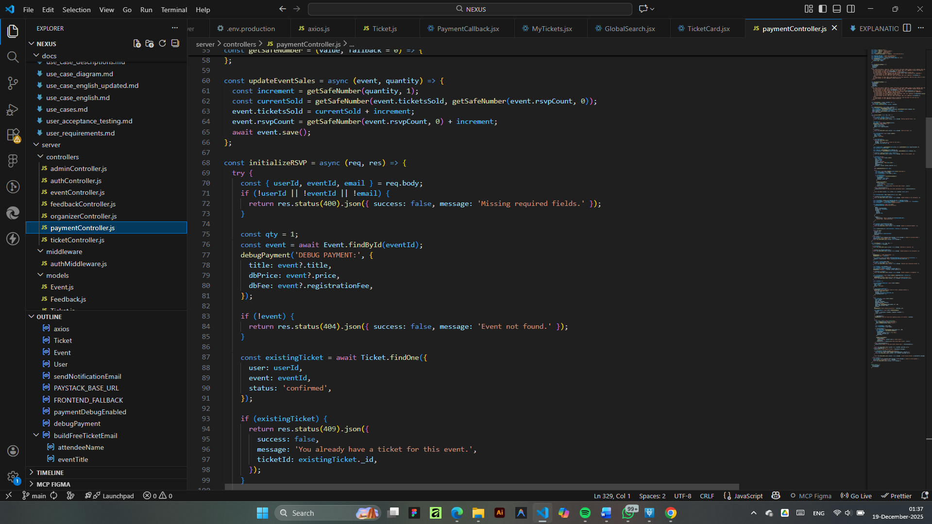

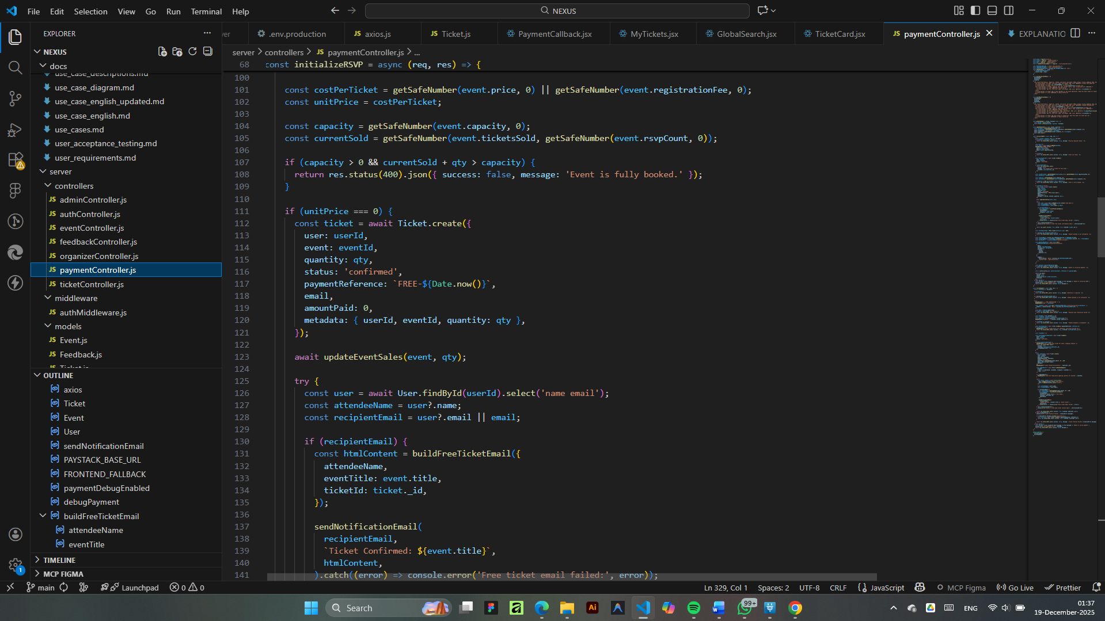

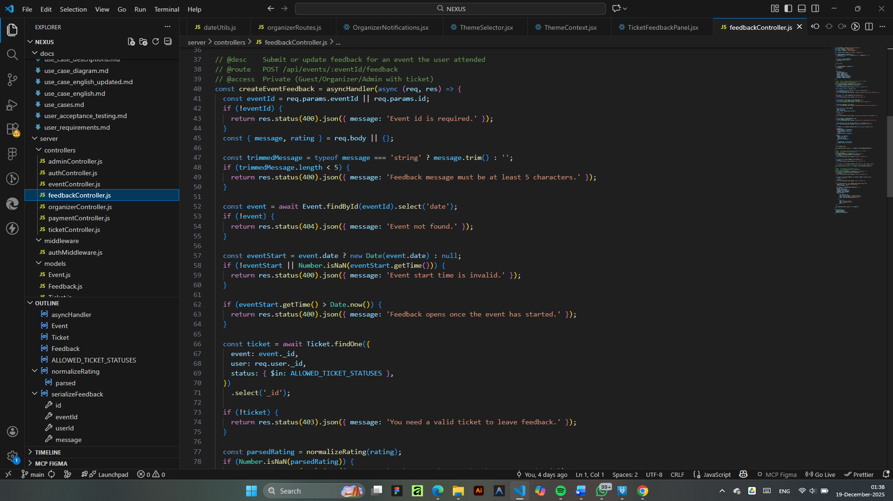

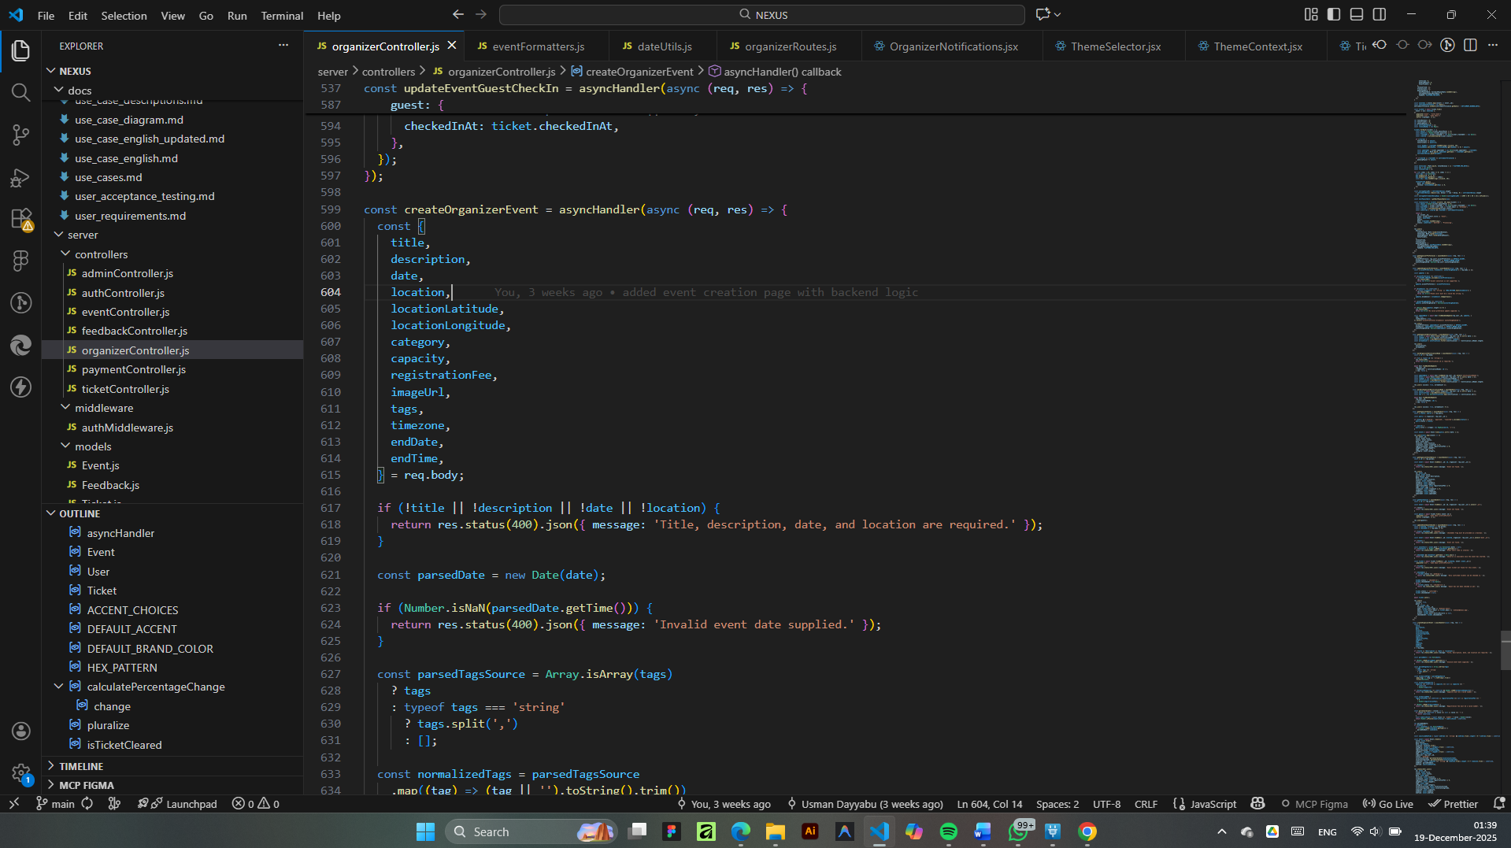

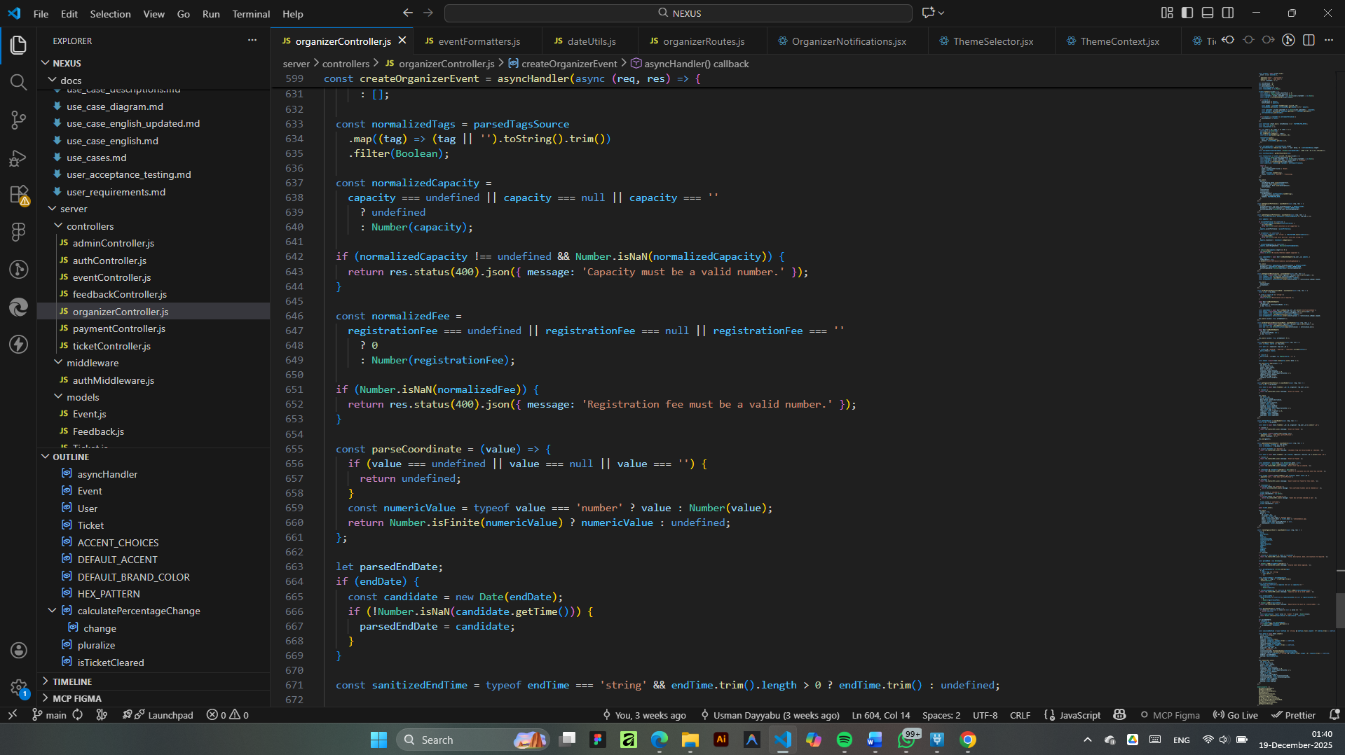

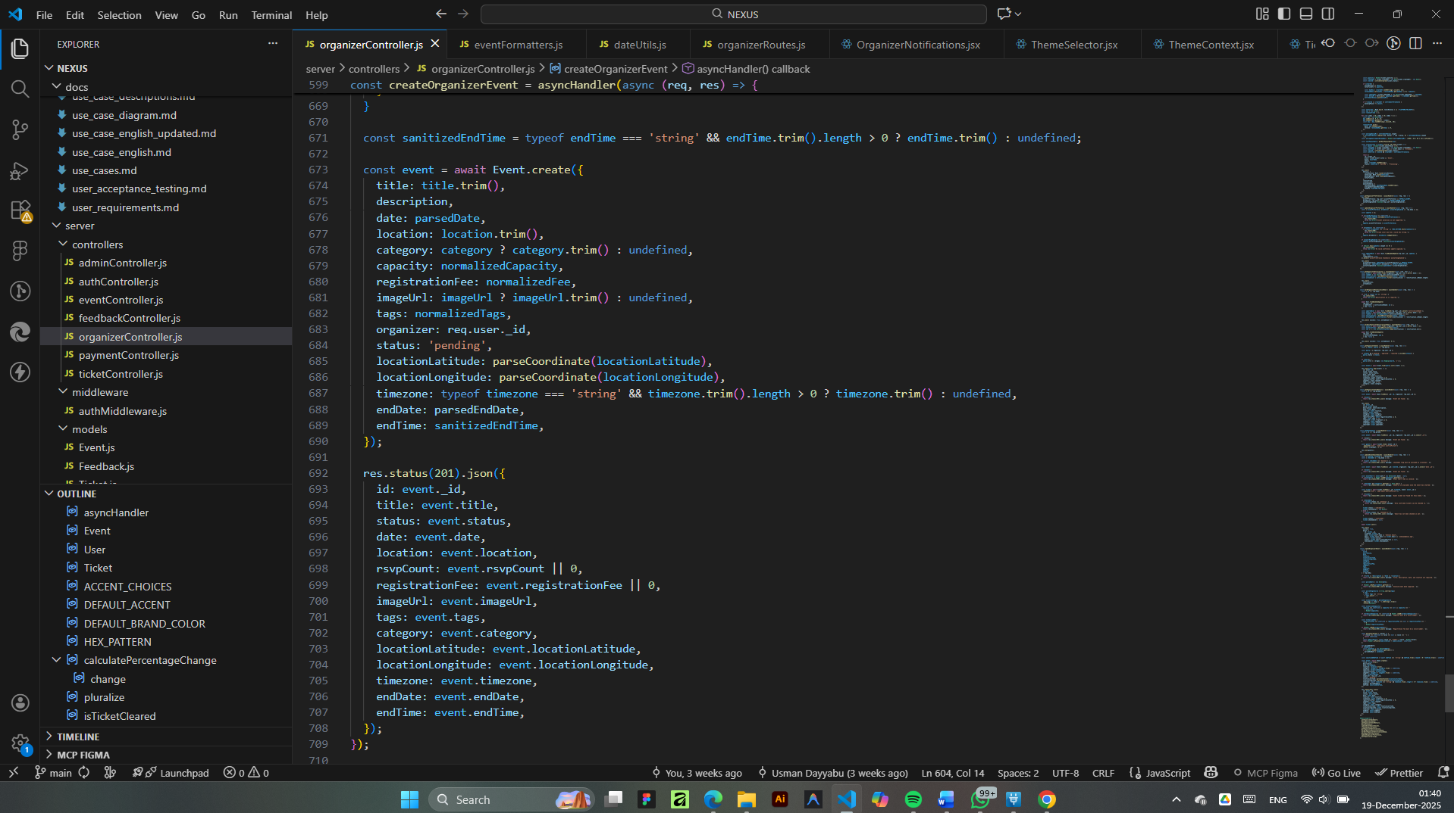

# APPENDIX C: SYSTEM TESTING QUESTIONNAIRE

| **Part A: Participant Details** |  |
| --- | --- |
| Test ID: ___________ | Date: ___________ |
| User Role: [ ] Student [ ] Organizer | Device Used: [ ] Laptop [ ] Mobile Phone |

| **Part B: Task Execution Checklist** |  |  |
| --- | --- | --- |
| **Task Description** | **Did you succeed?** | **Difficulty (1-5)** |
| Task 1 (Discovery): Navigate to the dashboard and use the "Category Filter" to find a Sports event. | [ ] Yes [ ] No | 1 2 3 4 5 |
| Task 2 (Booking): Open the event details and successfully Book a Ticket (RSVP). Check if you receive a confirmation. | [ ] Yes [ ] No | 1 2 3 4 5 |
| Task 3 (Creation - Org Only): Log in as an Organizer, click "Create Event," and use the Map Auto-complete to set a venue. | [ ] Yes [ ] No | 1 2 3 4 5 |
| Task 4 (Responsiveness): Resize your browser window or use a mobile phone. Is the text readable and the layout clear? | [ ] Yes [ ] No | 1 2 3 4 5 |
| Task 5 (Performance): Click through three different pages (Home, Map, Tickets). Did the pages load quickly? | [ ] Yes [ ] No | 1 2 3 4 5 |

| **Part C: Qualitative Feedback** |
| --- |
| 1. What was your specific observation regarding the booking confirmation? |
| *(e.g. "The confirmation message was reassuring...")* |
|  |
| 2. How would you describe the navigation speed? |
| *(e.g. "Pages loaded without lag...")* |
|  |
| 3. General Comments / Issues Encountered: |
| **_________________________________________________________________________** |
| **_________________________________________________________________________** |